Introduction

*This report will outline the theoretical overview of the Kalman Filter. I appreciate that there has been a lot of discussion on it over the last month, however, there are a few fundamental points that I want to explore further, as I think they are absolutely paramount to successfully implementing something like this.*

*The main points I want to address are:*

1. *The Filter is a form of ‘Polynomial Function’*
2. *The distinction between ‘Actual Levels’ and ‘Measurement Levels’. The latter being an estimate/predictor of the former.*
3. *Using the Filtered Data over the Unfiltered data for scoring only*
4. *Deleting Data that is deemed spurious*

*The points above are pretty crucial in the adoption and implementation process. If navigated incorrectly, the Filter I believe is not workable. For this reason, I want to address the issues head on. That being said, I’m still constantly questioning my own processes, so any input you have is always welcome.*

*Finally, I will present the results. Note the exclusion periods have been left alone for comparability.*

*Polynomial Function?*

*The Filter does not smooth data. It’s an Iterative* ***Linear Transformation*** *at each data point. It is possible to increase the power of the filter for non-linear systems using a non-linear transformation using the Extended Kalman Filter. Owing to time constraints and complexity I have avoided this approach.*

*However, in your suggestion that there was a polynomial mapping, alarm bells were going off in my head, specifically that you were comparing the filter with techniques to ‘fit’ the data, hence the creeping in of terminology such as ‘smoothing’. The Filter is doing something fundamentally different. This point may seem subtle, but its critical. For this reason, I’ve illustrated the point below using a thought experiment. I will then show you using a simplistic quasi mathematical proof as to what the filter is trying to achieve.*

*Imagine the blue points are the data from the sensor. The dotted Line is the Trend Line (this could be anything, exponential fitting/polynomial fitting). At X equals 1, what is the* ***Estimate of the Actual Level in the Tank?***

1. *2.75?*
2. *4.4?*

*The answer is 1, and is the point (I think) you were making last week when we spoke. Specifically, that although my Kalman filter is saying 4.4, the actual level is 2.75. The sensor data is the most accurate* ***Estimate of the Actual Level.*** *It is an Estimate because the sensor may be inaccurate. The Trend line is simply a proxy should we ever need to make a prediction (in this case it is a poor one).*

*Now imagine, and this is important, the dotted line is no longer the Trend Line, but is the output from the Kalman Filter. What is the* ***Estimated Actual Level?***

1. *2.75?*
2. *4.4?*

*The answer is 4.4, which I admit seems counter intuitive. The important principle here is that filtered sensor data is better than the original sensor data in asking the question: “what is the true state of the system?”. But why?*

*\*please note when we last spoke, I was still in the process of calibrating the Filter, hence why the peaks where significantly undershooting. This is now fixed.*

Sensor Data is an **Estimate of The Actual**

*Data received from the sensors is defined as the* ***Measurement Level data.*** *It purports to estimate what the Actual Level in the system is.*

$Measurement Level=Actual Level+$ $E$

*Where $E$ is the noise in the system. We assume noise to take a Gaussian distribution.*

**Note:**

$$If: Measurement Level=Actual Level+ E$$

$$Then: Measurement Level ≠Actual Level$$

*In using the prefiltered data in our models we are assuming that the Estimate of the Actual Level is equal to the Measurement Level:*

$$\hat{Actual}=Measurement Data$$

*If we could strip out the noise by trying to remove $E$ then :*

$$\hat{Actual}= Measurement Data+Kalman Filtering$$

***Fundamental:*** *The output of the Kalman filter is an Estimate of the Actual Level. The raw data received from the sensor, the Measurement Data, is* ***also*** *an Estimate of the Actual*

$$\hat{{Actual}_{prefiltered}}=Measurement Data$$

$$\hat{{Actual}_{Filtered}}=Measurement Data+Kalman$$

$$\hat{{Actual}_{Filtered}} has lower variance to {Actual}_{prefiltered} therefore we should always use the$$

**The former as it should be more accurate.**

*This means that:*

1. *We should not train our models using prefiltered data*
2. *Not score our models on prefiltered data*
3. *Not map regressors produced using filtered data onto unfiltered data*

*I do agree with you that we should be able to still view the prefiltered data, as it still offers us important information on whether the sensors are under pressure/benching/broken. Being able to view both types of data in the portal I think is the way forward.*

Deleting ‘obviously’ wrong data is better than leaving it in?

*The Kalman Filter needs to understand the distribution of the noise in order to function correctly. Noisy data which is ‘obviously’ wrong still provides important information about the distribution of the noise in the system, which subsequently allows us to strip it out when estimating the actual level in the Asset (using probability theory).*

*There is an argument to ignore missing data, or impute it over short periods, which I agree with. Also, in the rare event the Kalman output is negative, then this should be zeroed. Generally speaking, I would err on the side of caution when deciding to delete data, as I believe it could present a real risk of over fitting and I also worry that it’s not robust enough (could lead to accidentally deleting valuable data).*

*However, I do believe in excluding data that represents structural changes (blockages etc.). This is something which I have not fully addressed in this report, as I believe nailing down the cleansing process should take priority before addressing the exclusion events.*

Asset 16043_CSO (Ignore regressors for now. Just look at the SLM data)

*Data Prefiltered*

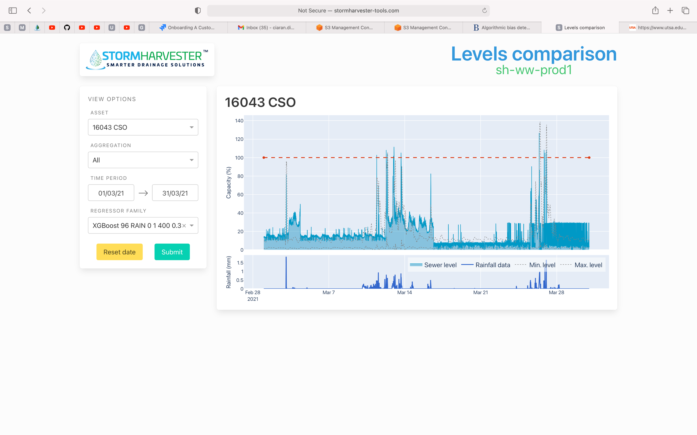

*Filtered*

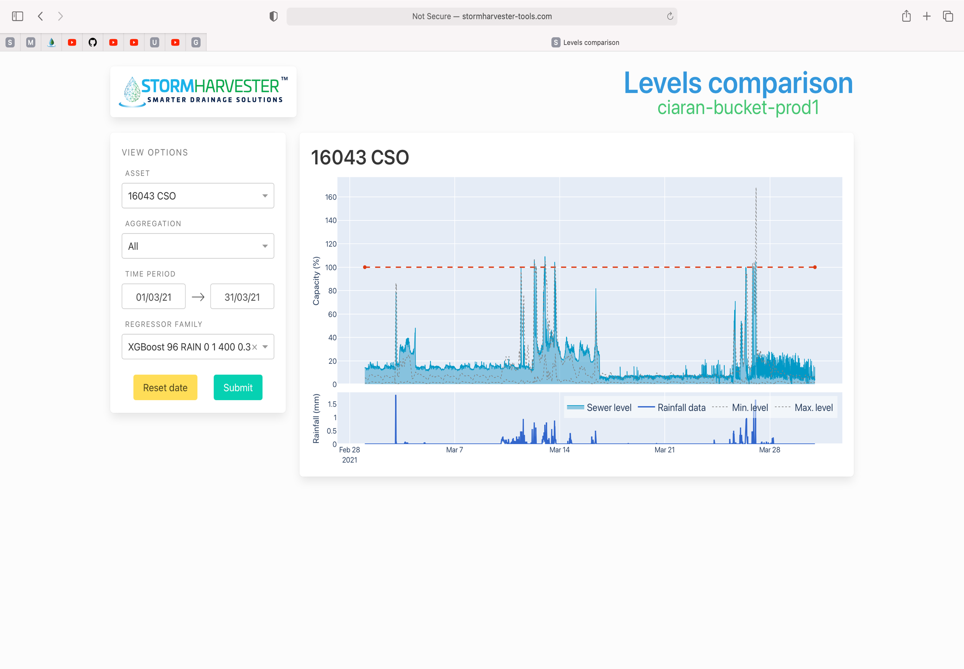

*Regressors (Old)*

*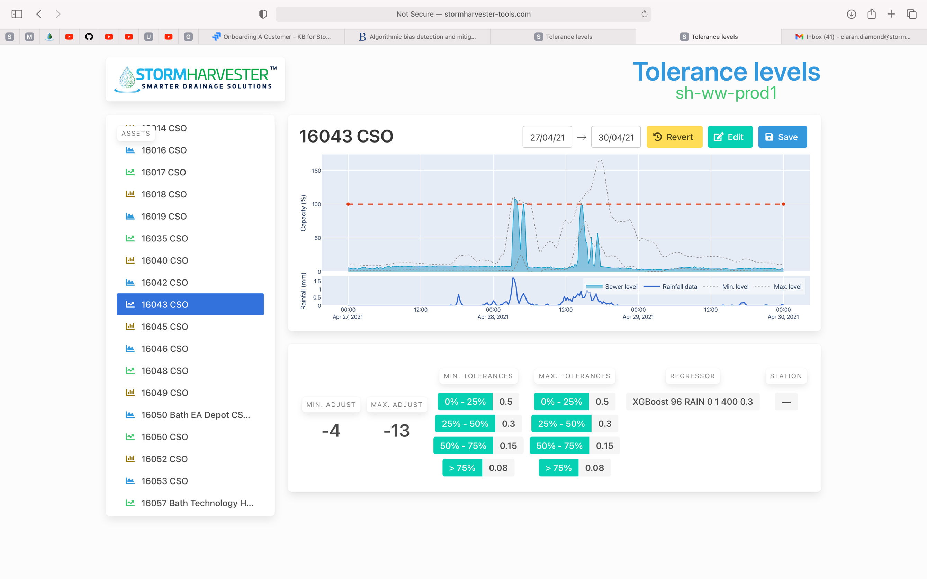Regressors (New)*

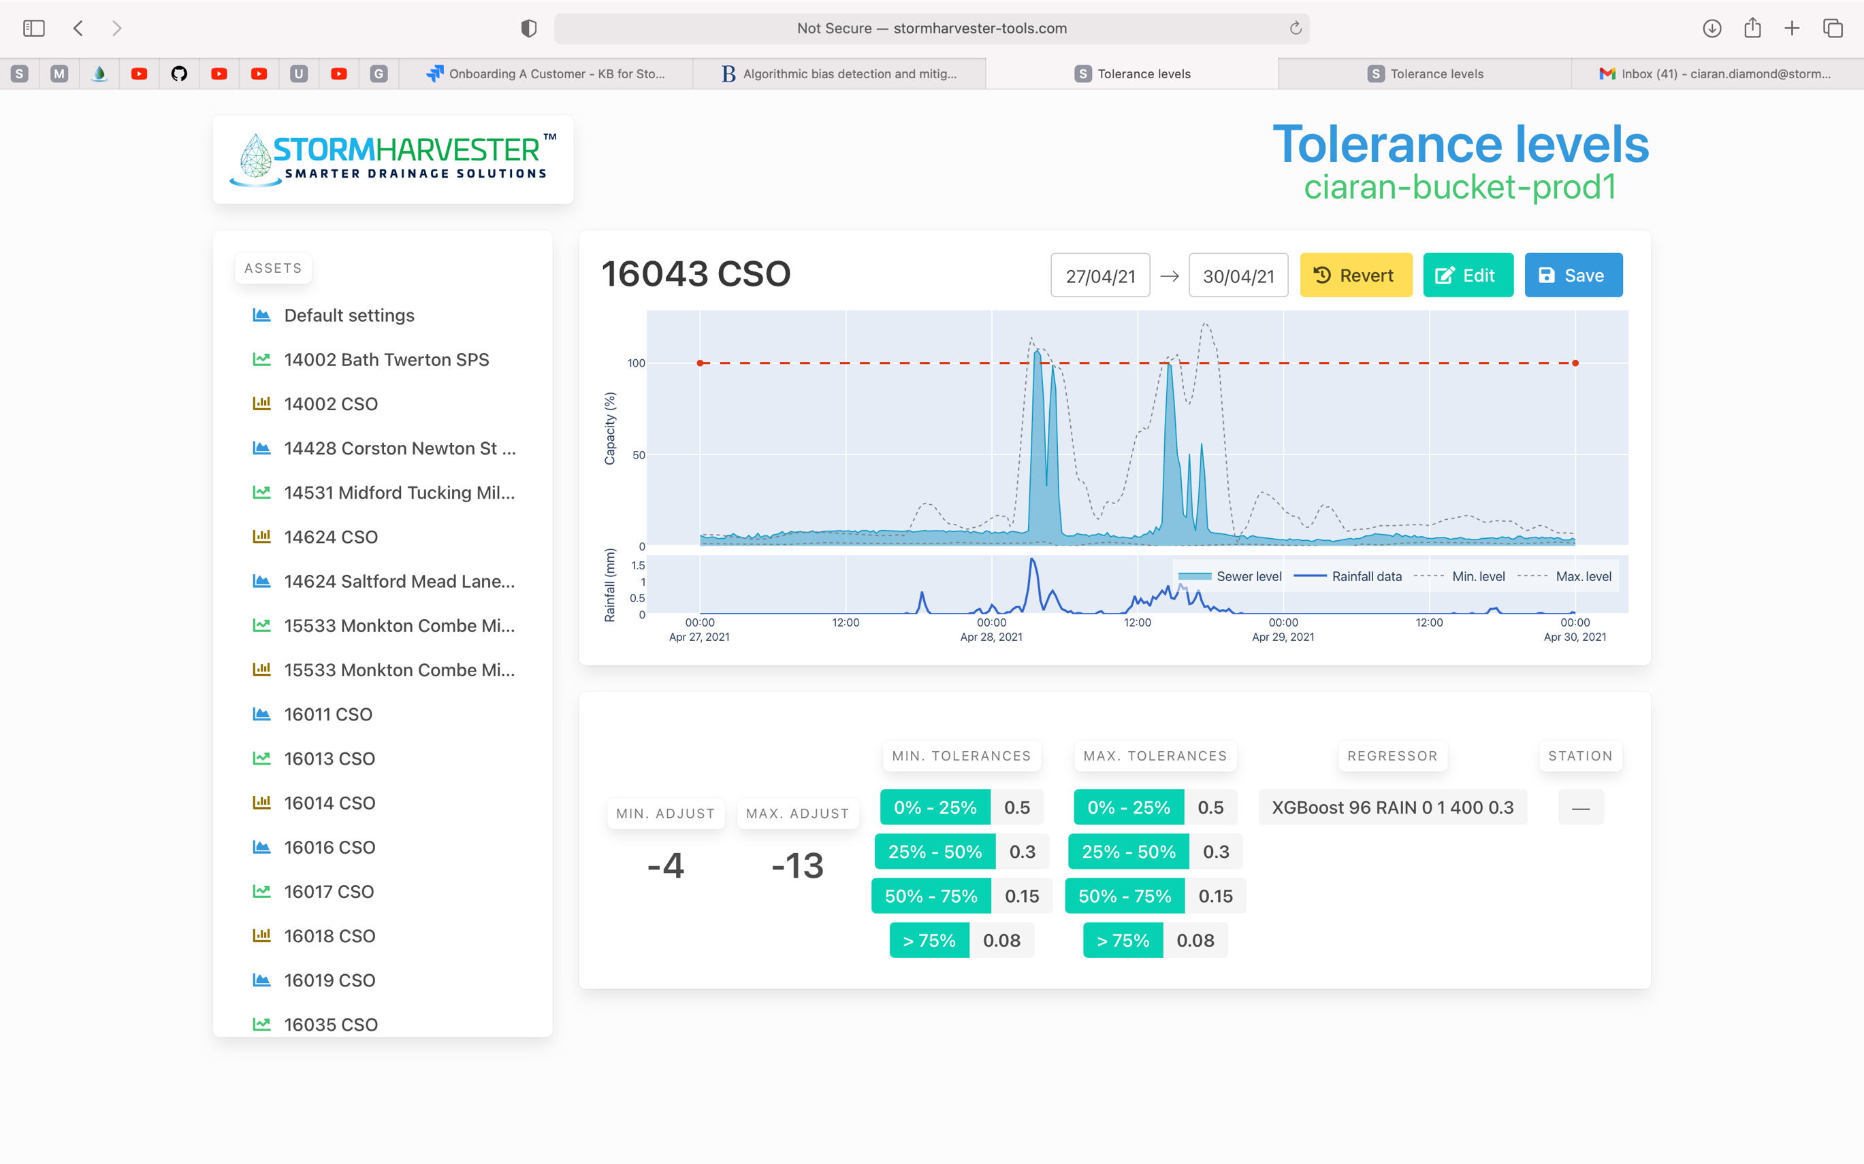

*Scores: Prefiltered Data*

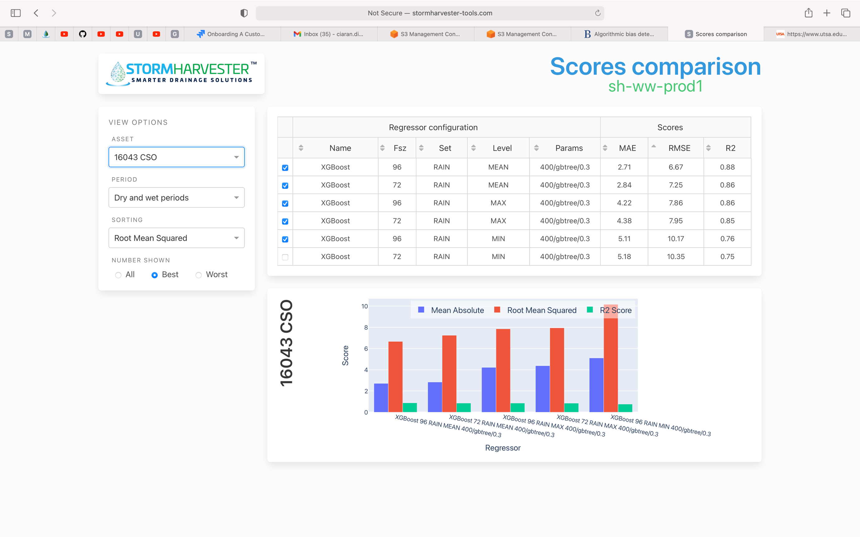

*Scores: Filtered Data*

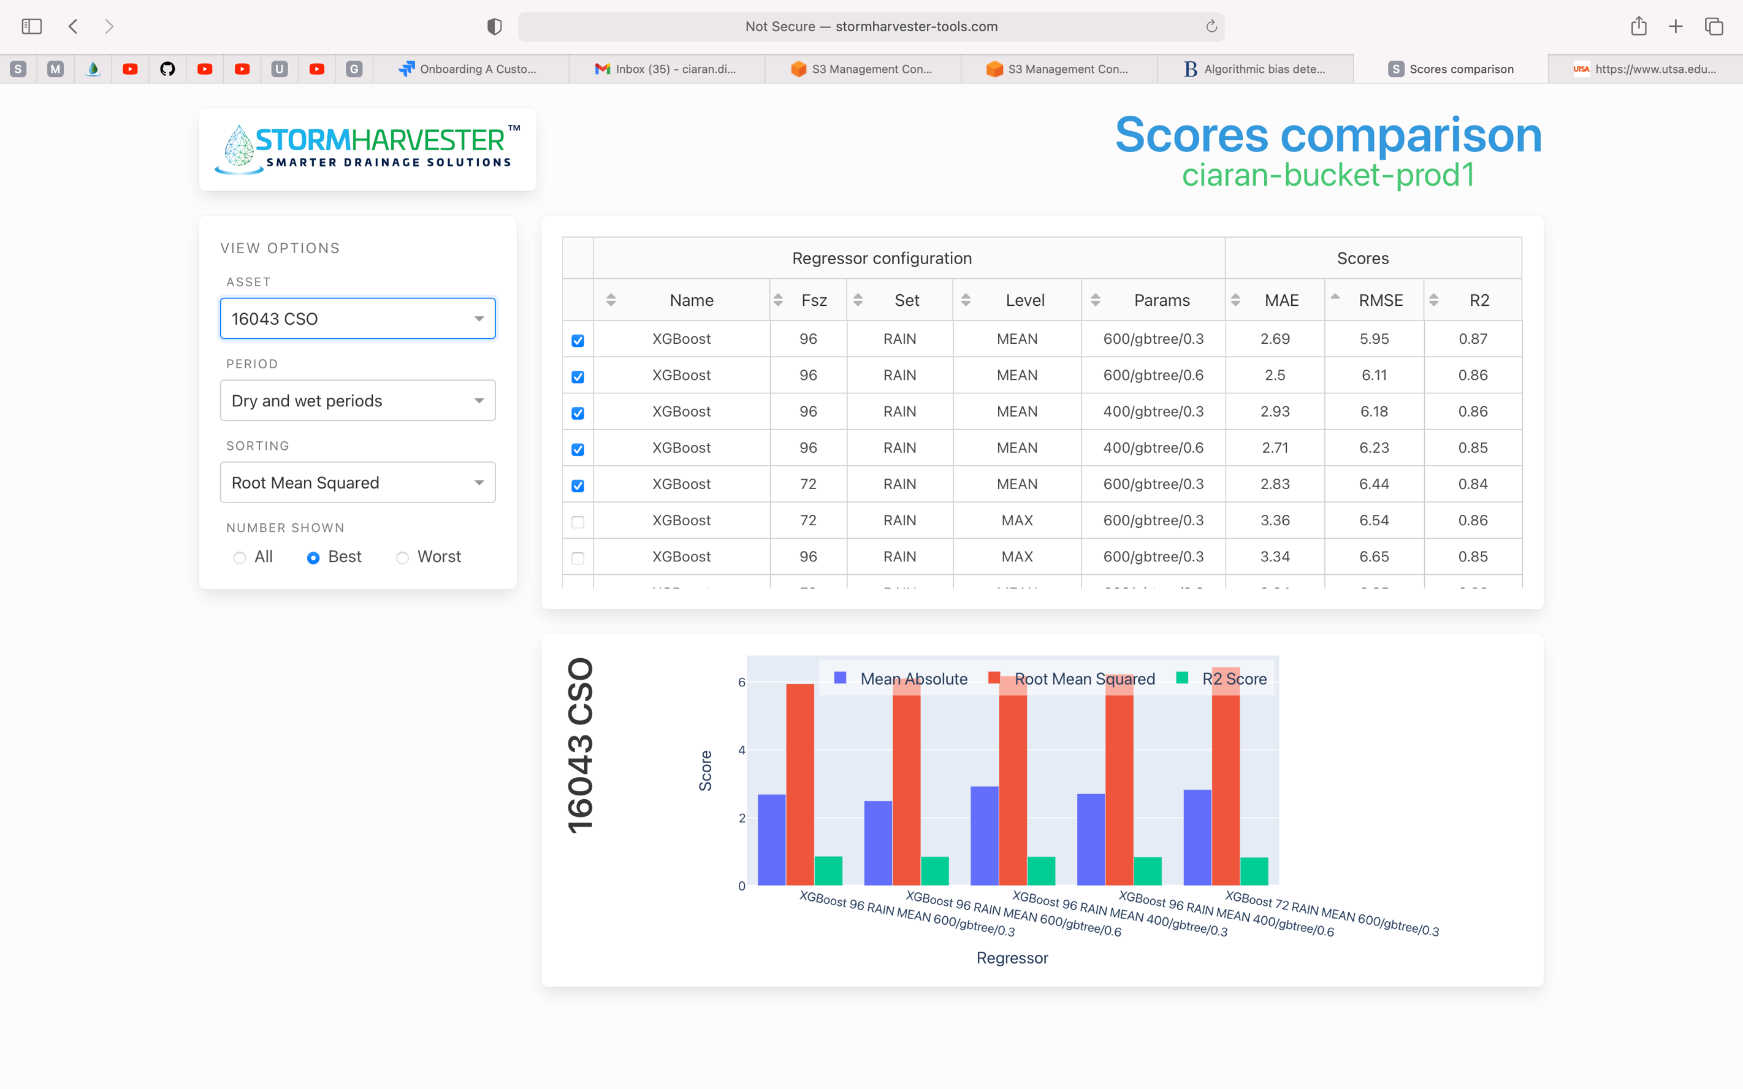

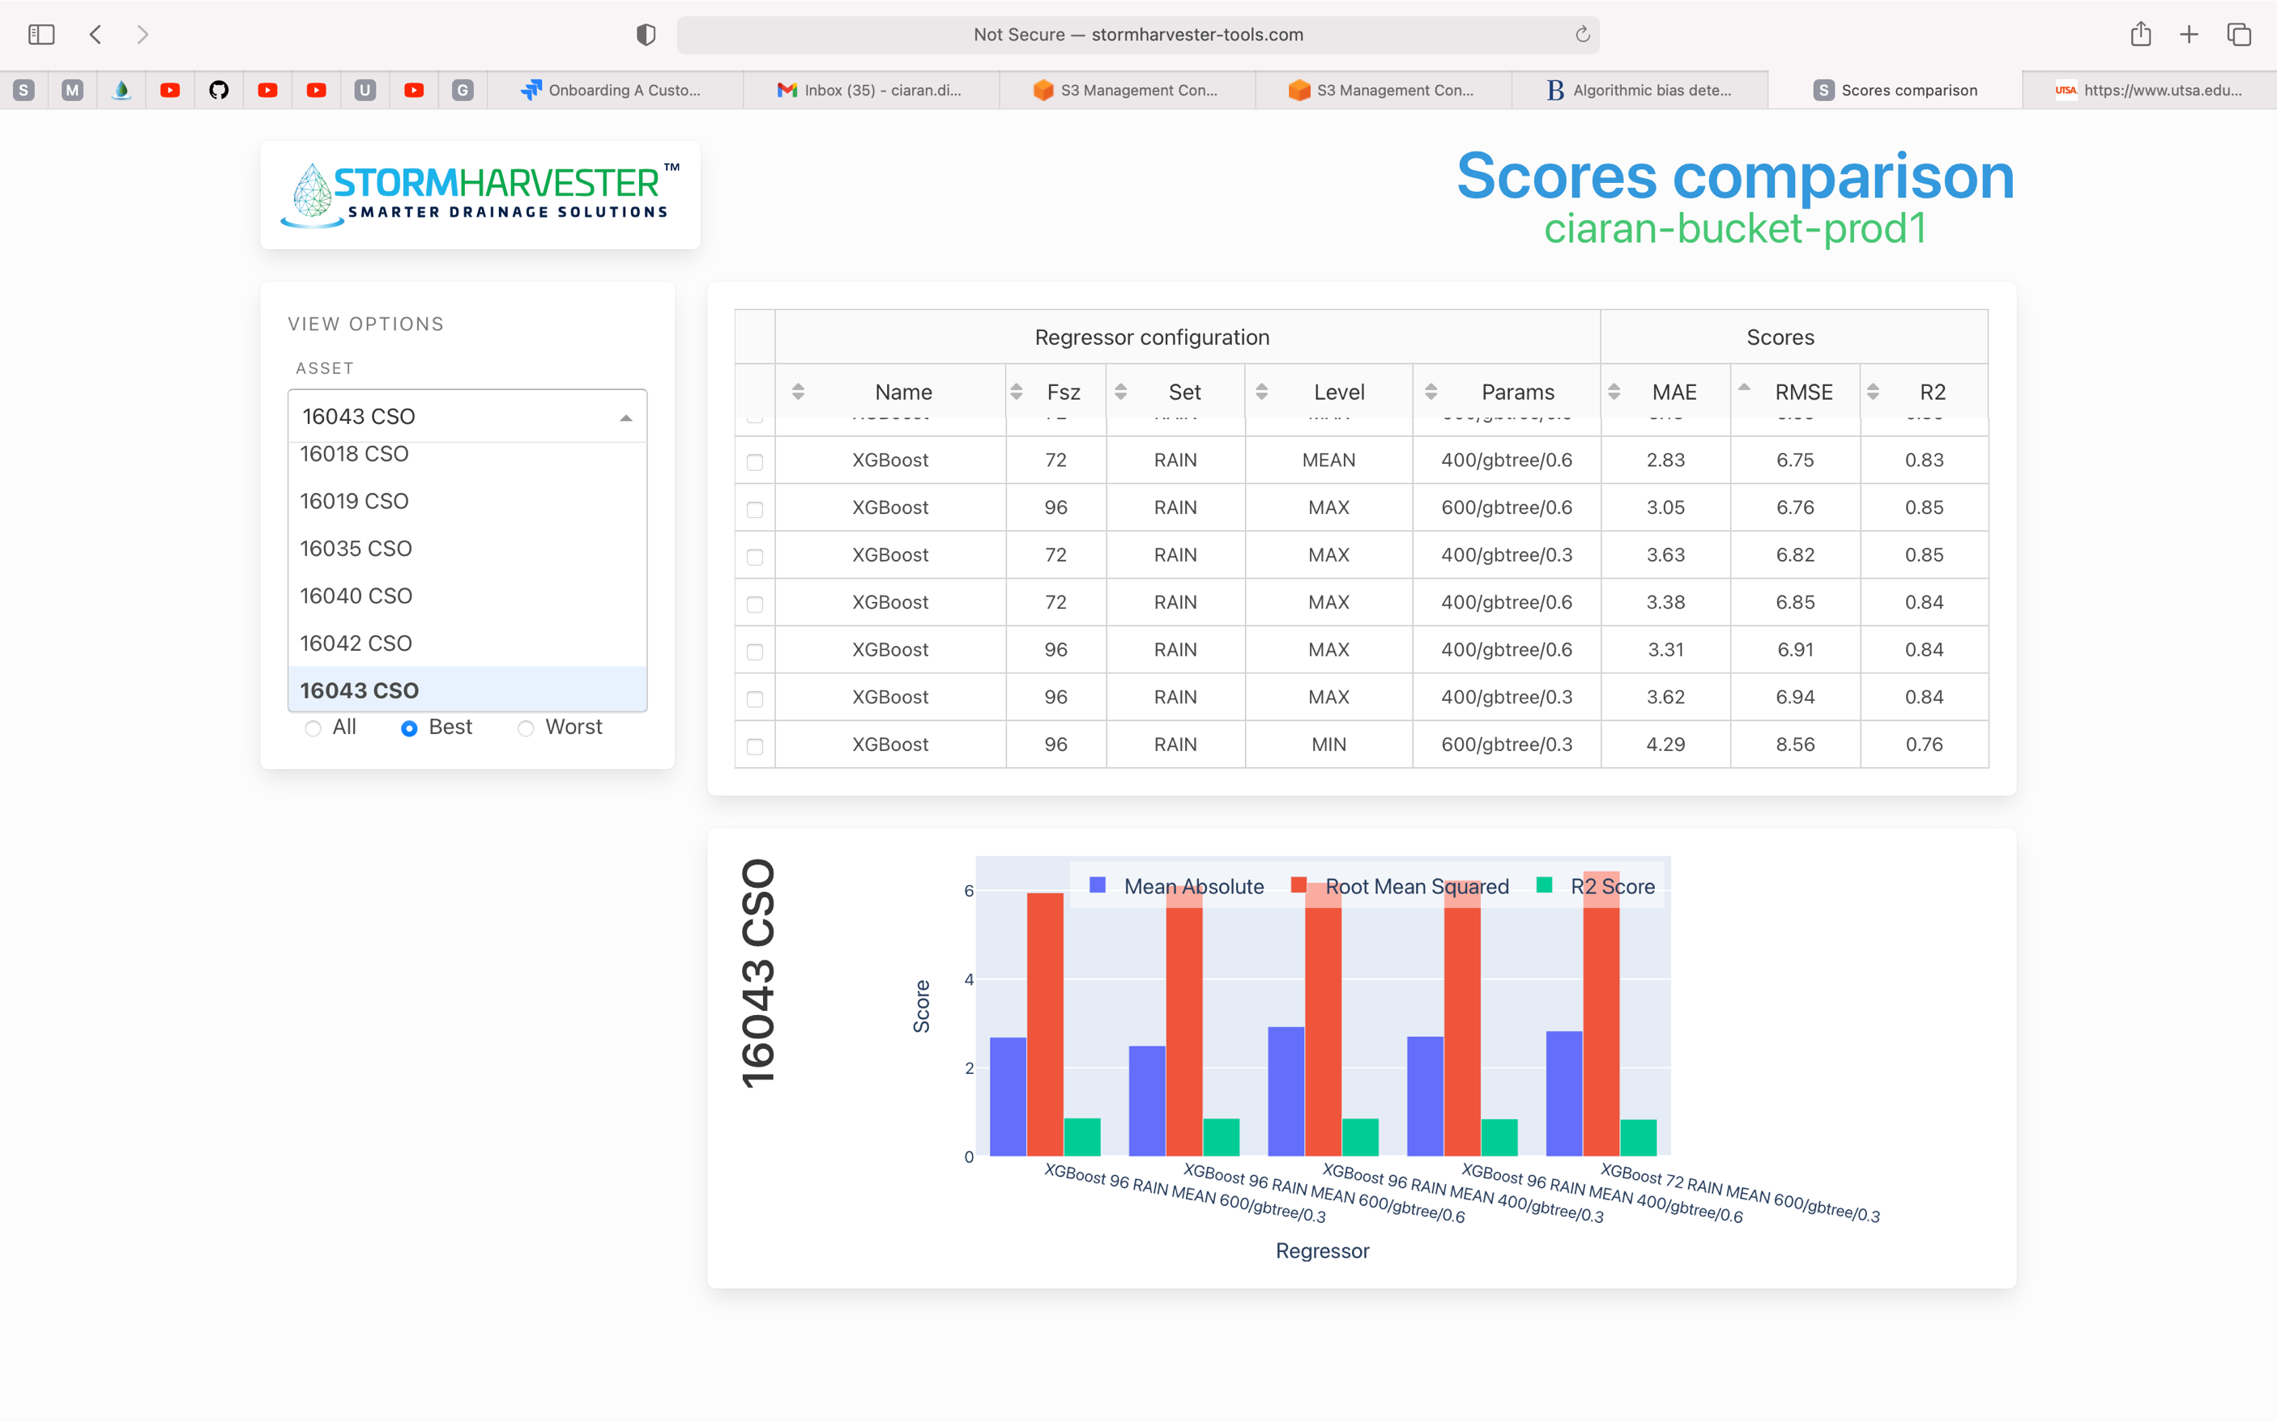

The Minimum and Maximum Regressors see some of the sharpest decreases in RMSE.

Asset 16057_CSO

*Step One: Remove noise from data using Kalman Filter*

*Step Two: Create Feature Sets using Levels Data (sid 53126)*

*Prefiltered Data (ignore predictions for now)*

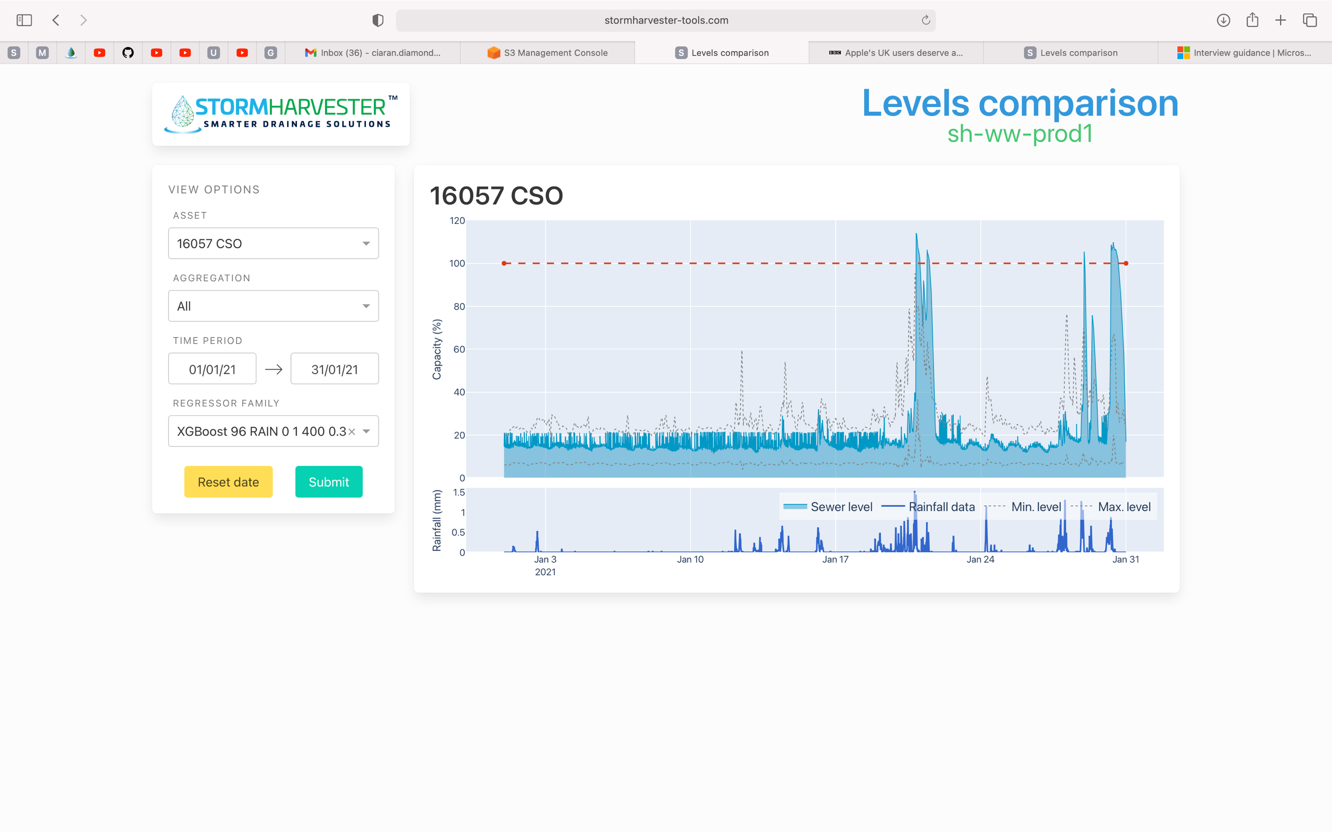

*Filtered Data*

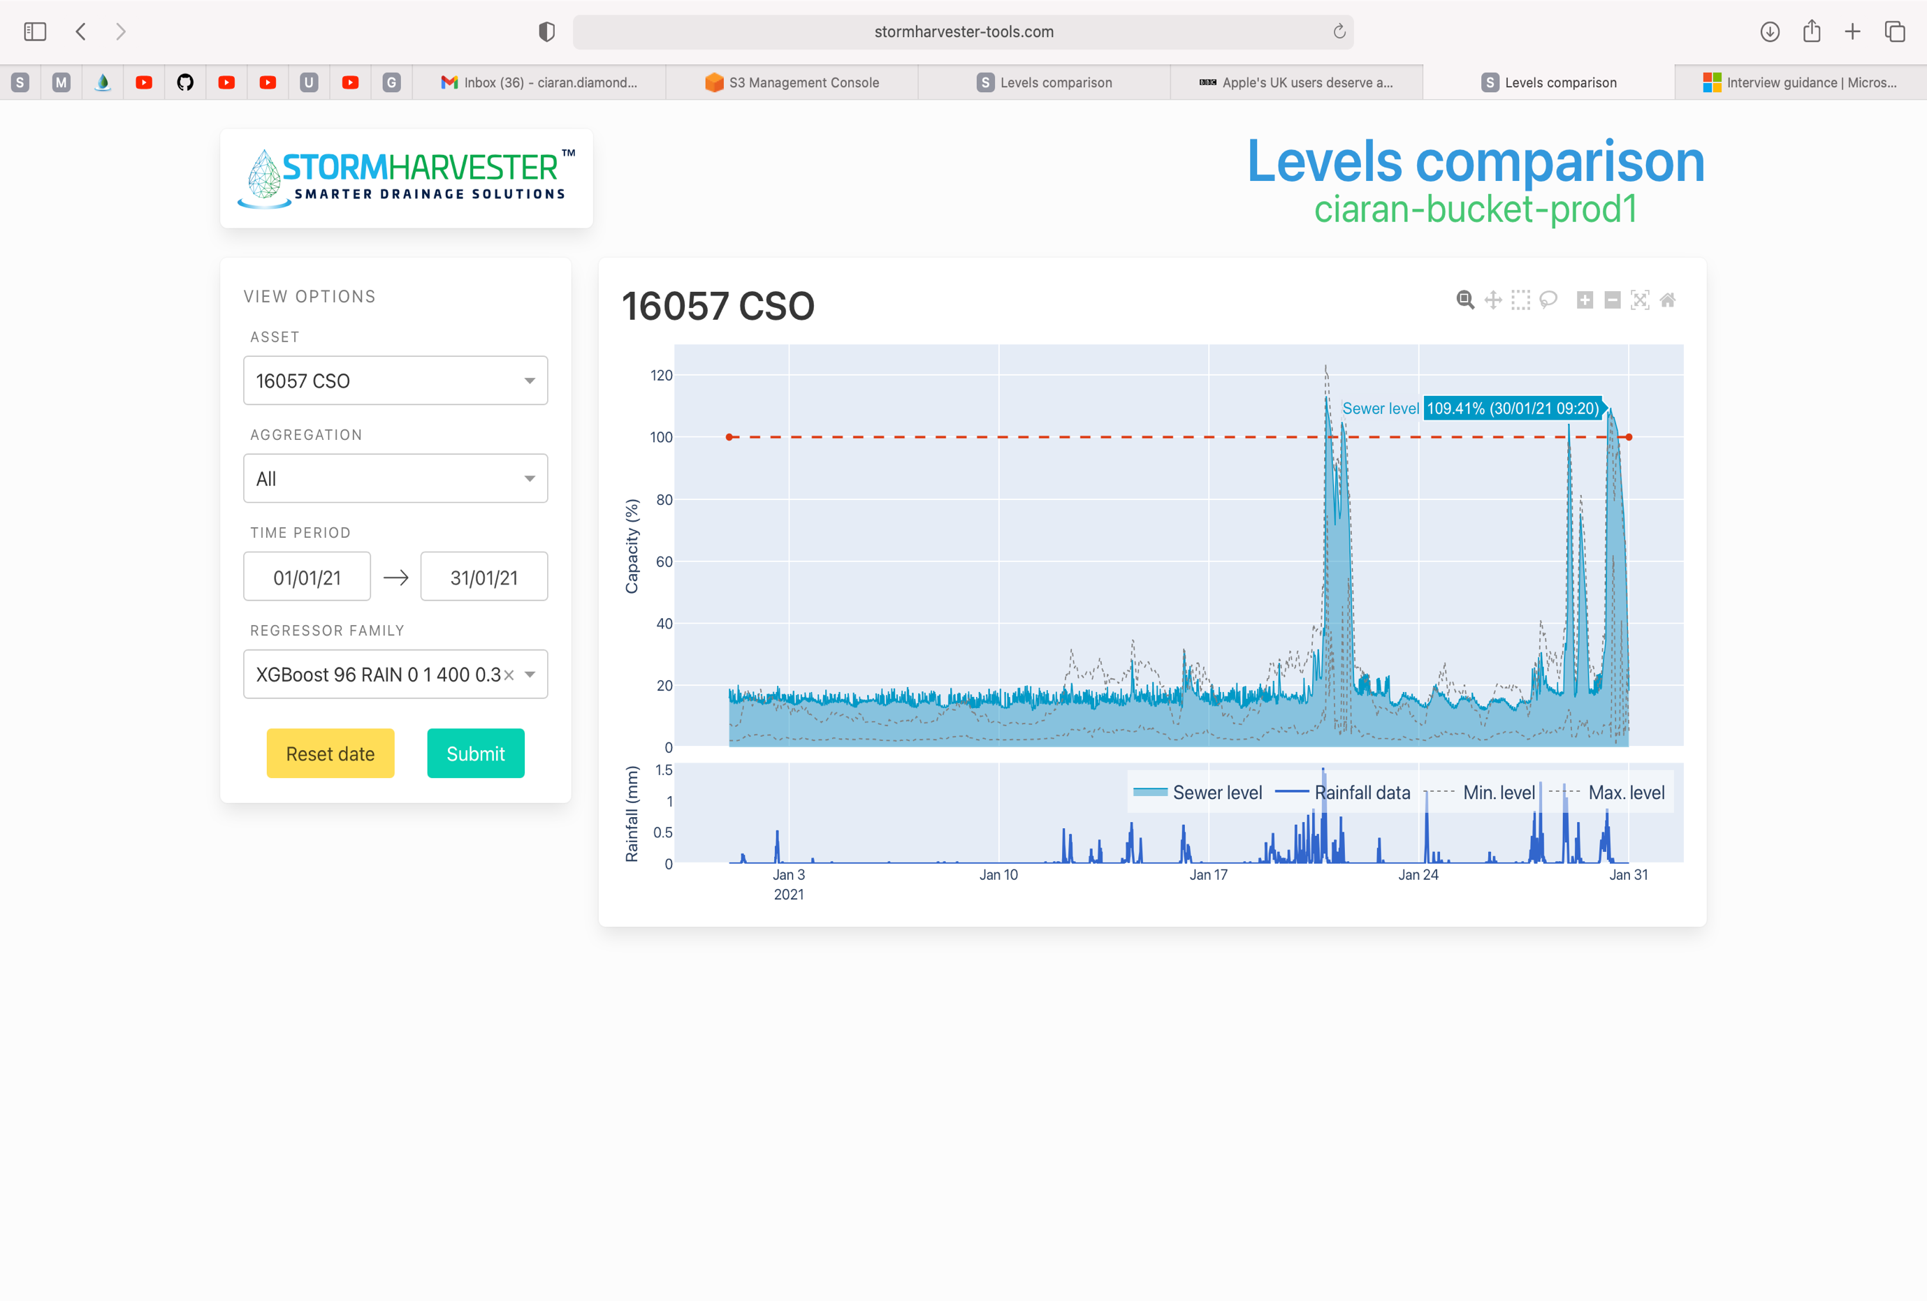

*Regressors*

*Before*

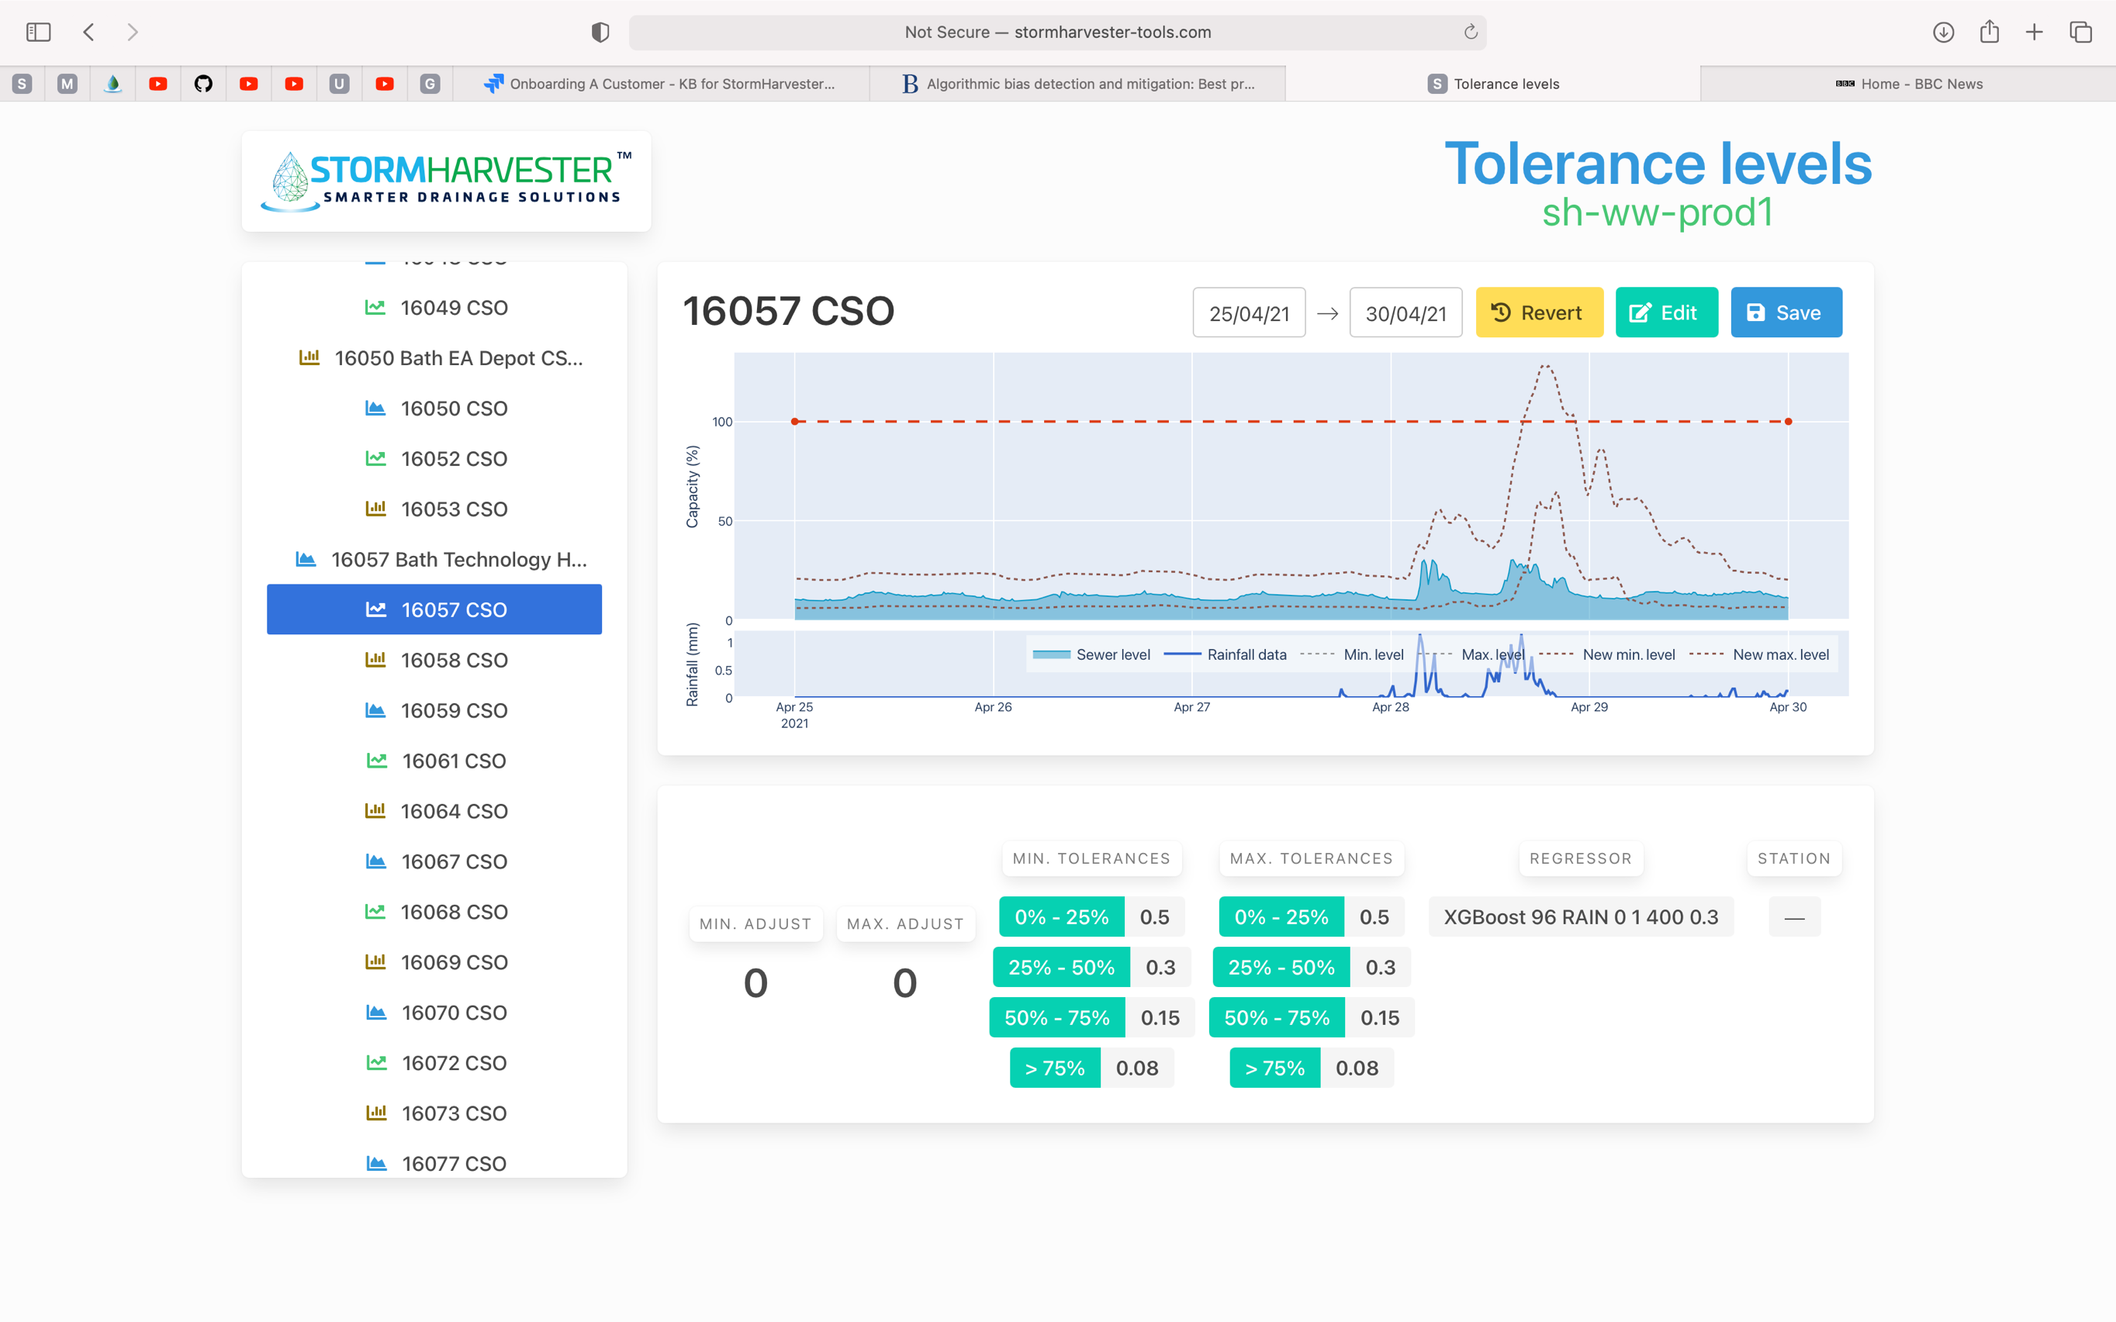

*After*

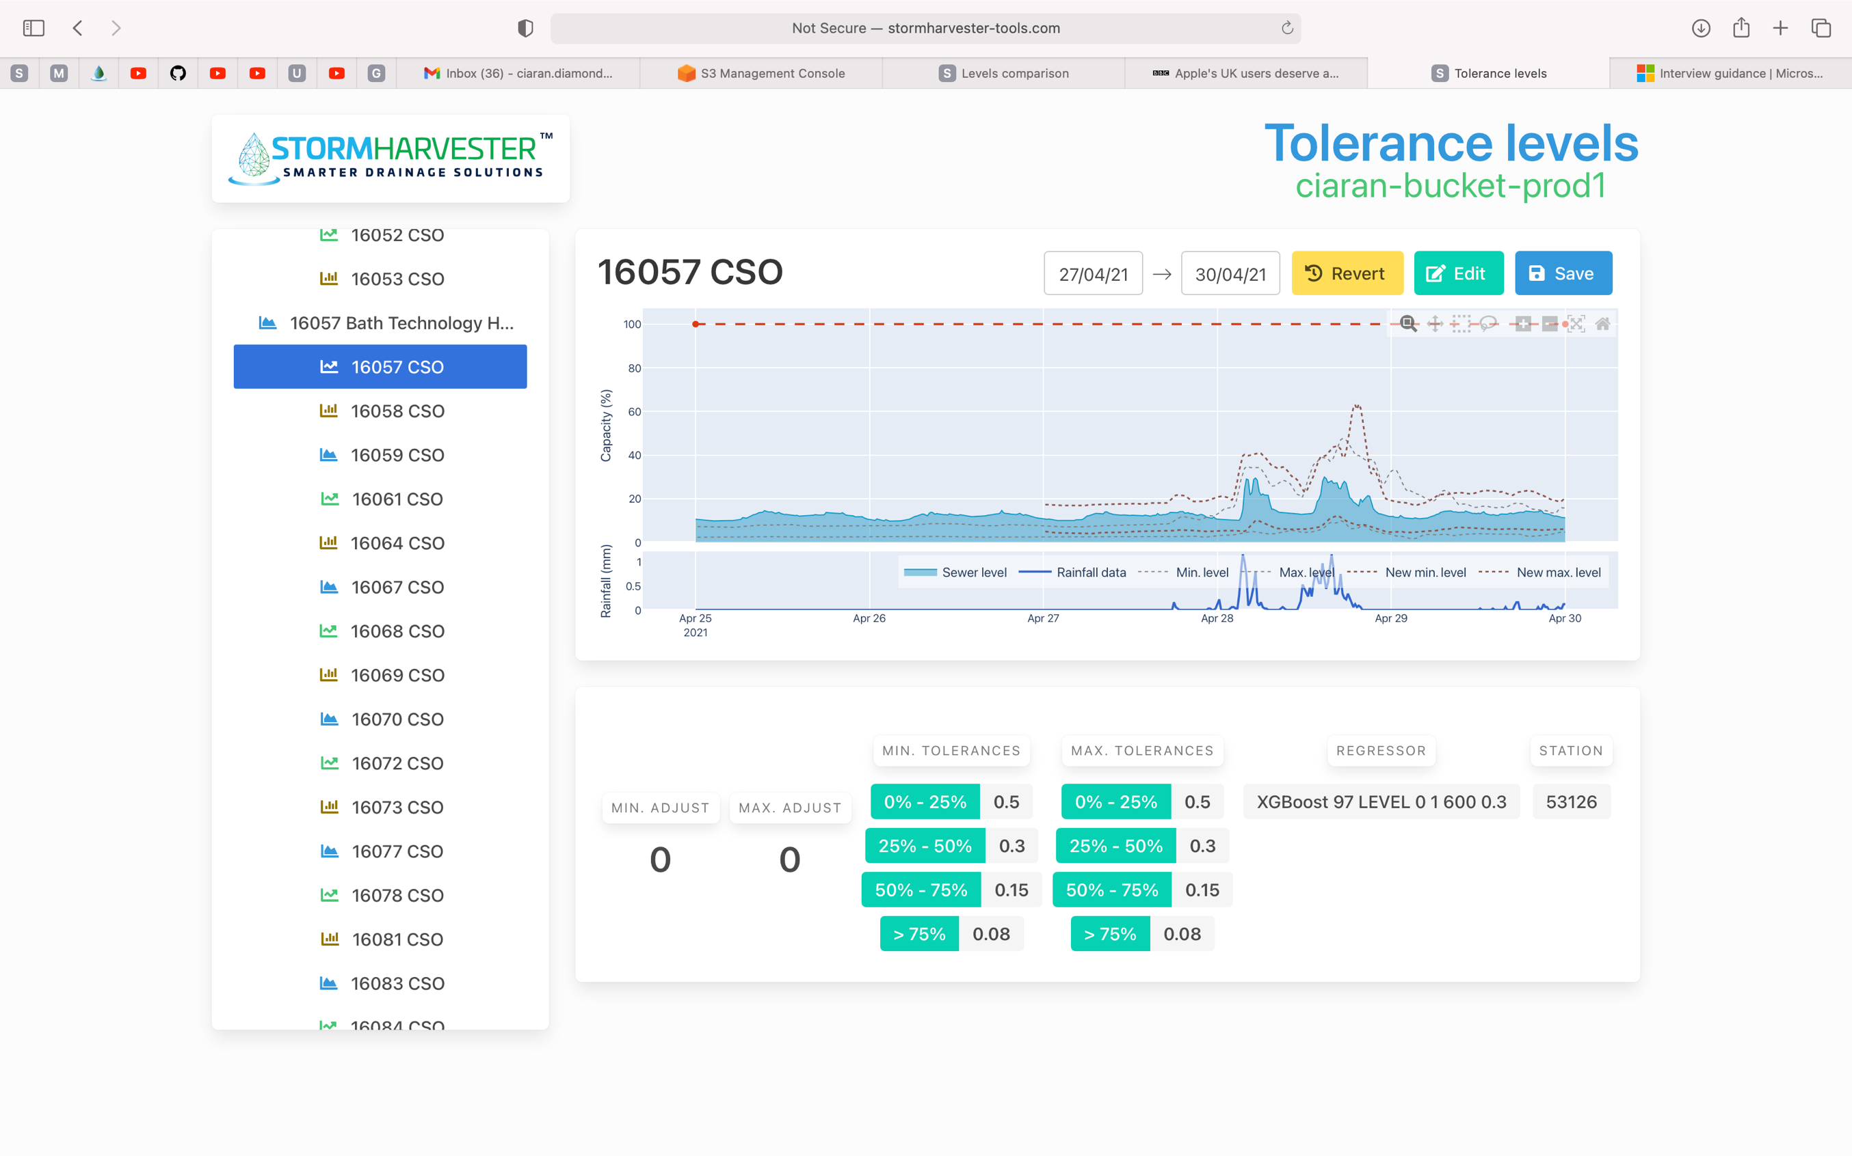

*The newly created regressors (73 & 97) are outperforming. Biggest gains seen for Max and Min regressors. Very large fall in maximum errors.*

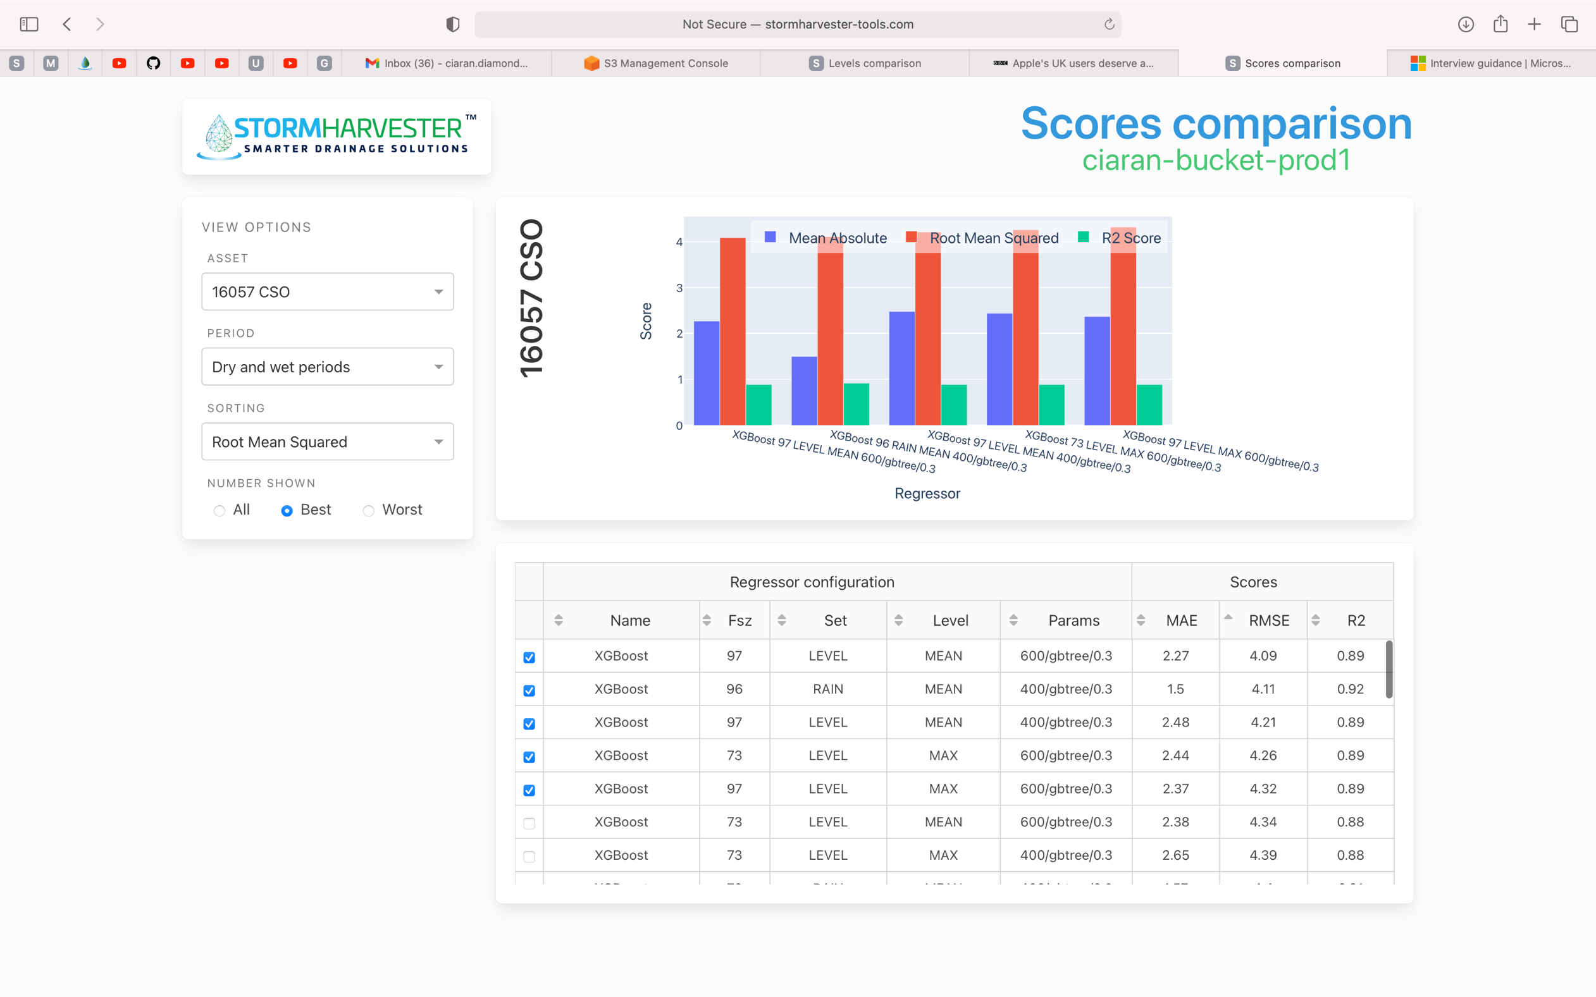

Asset 16040_CSO (ignore regressor)

*Before*

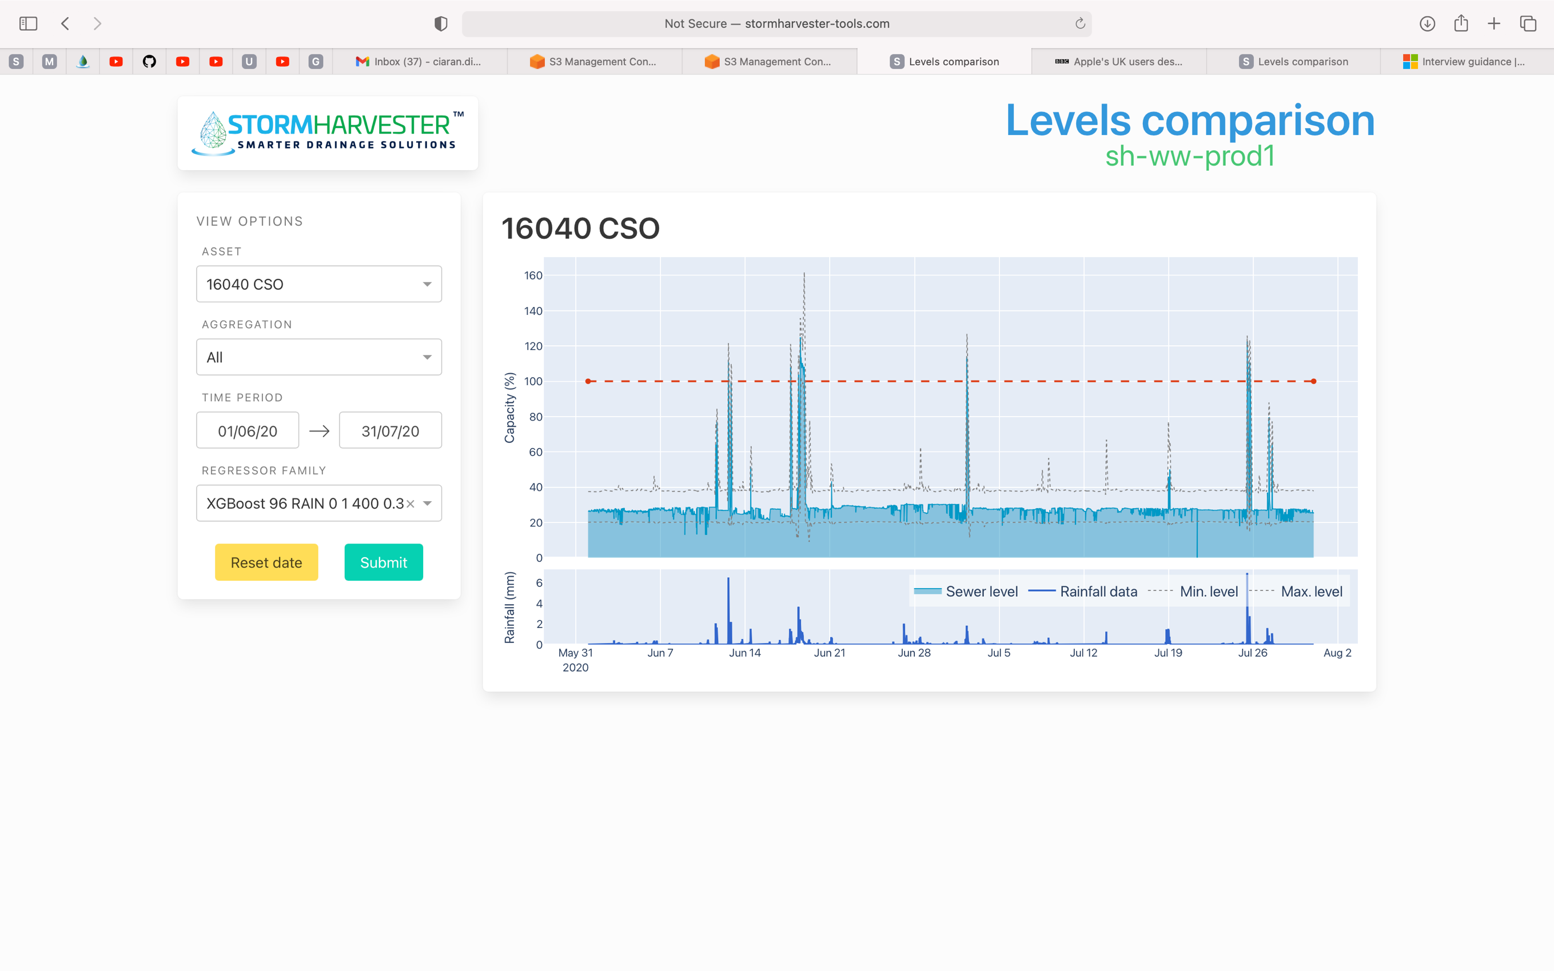

*After (negative value removed)*

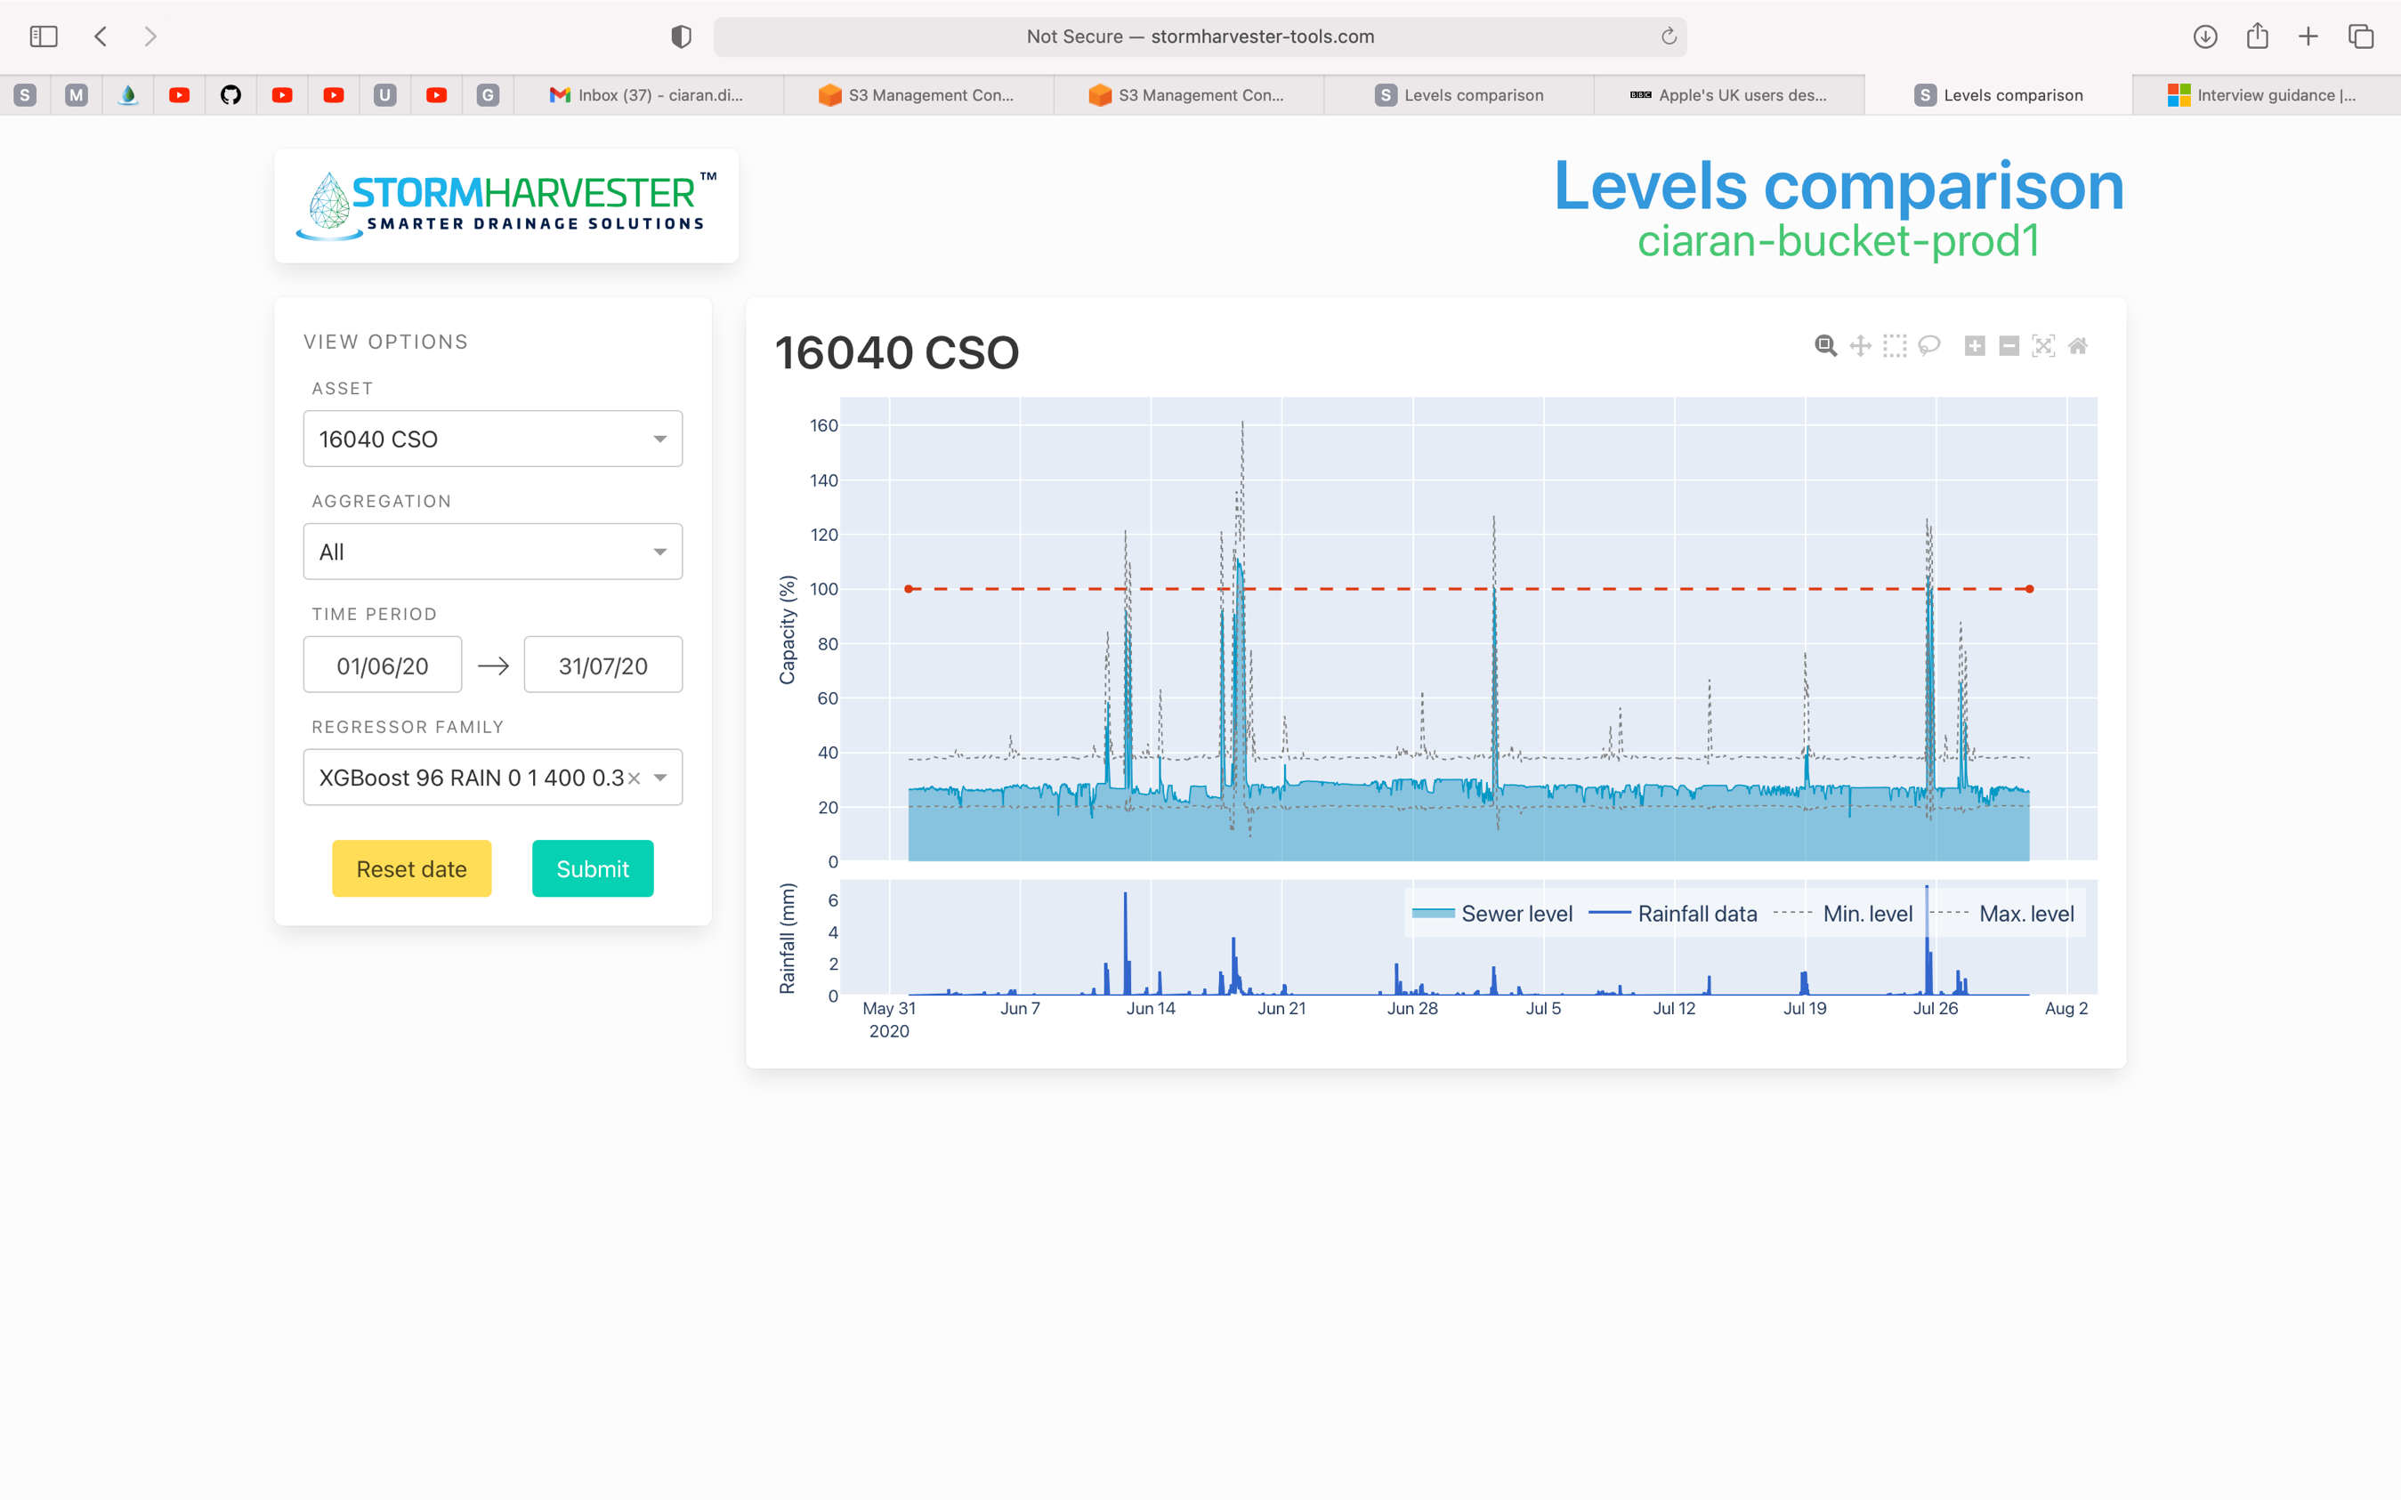

*Regressor (old regressor is the grey dotted)*

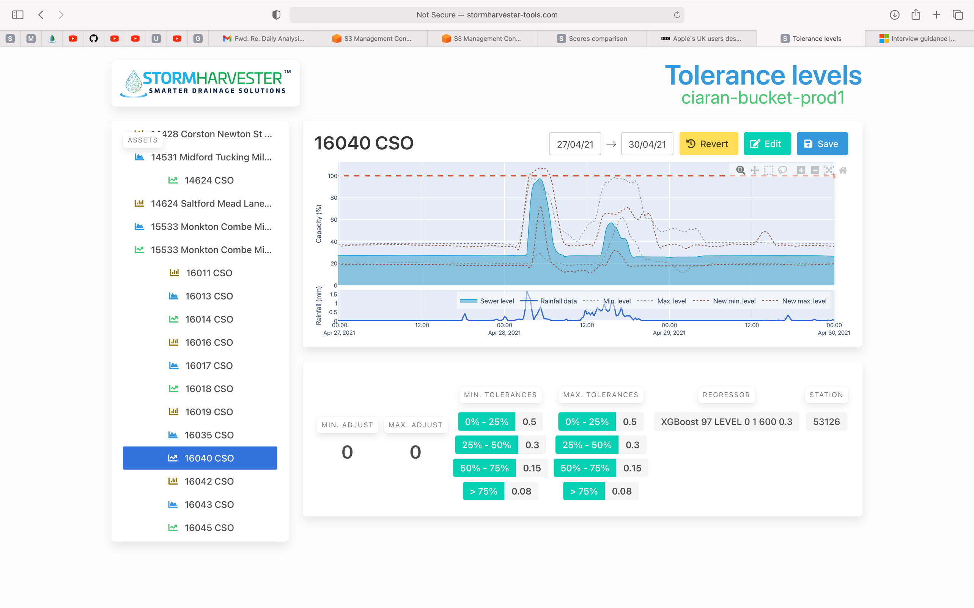

*Scores (Before)*

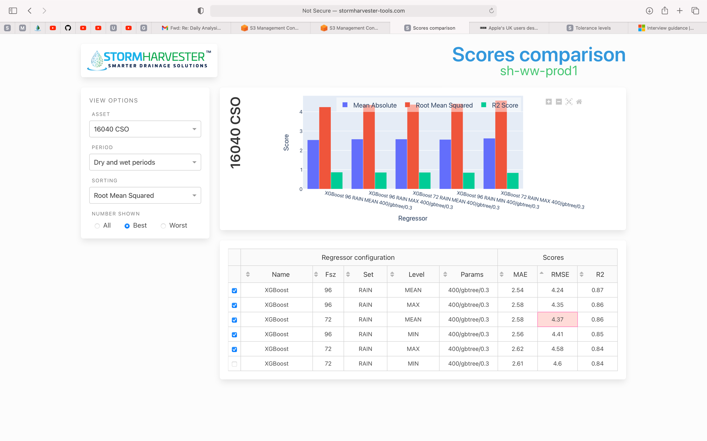

*Scores (After)*

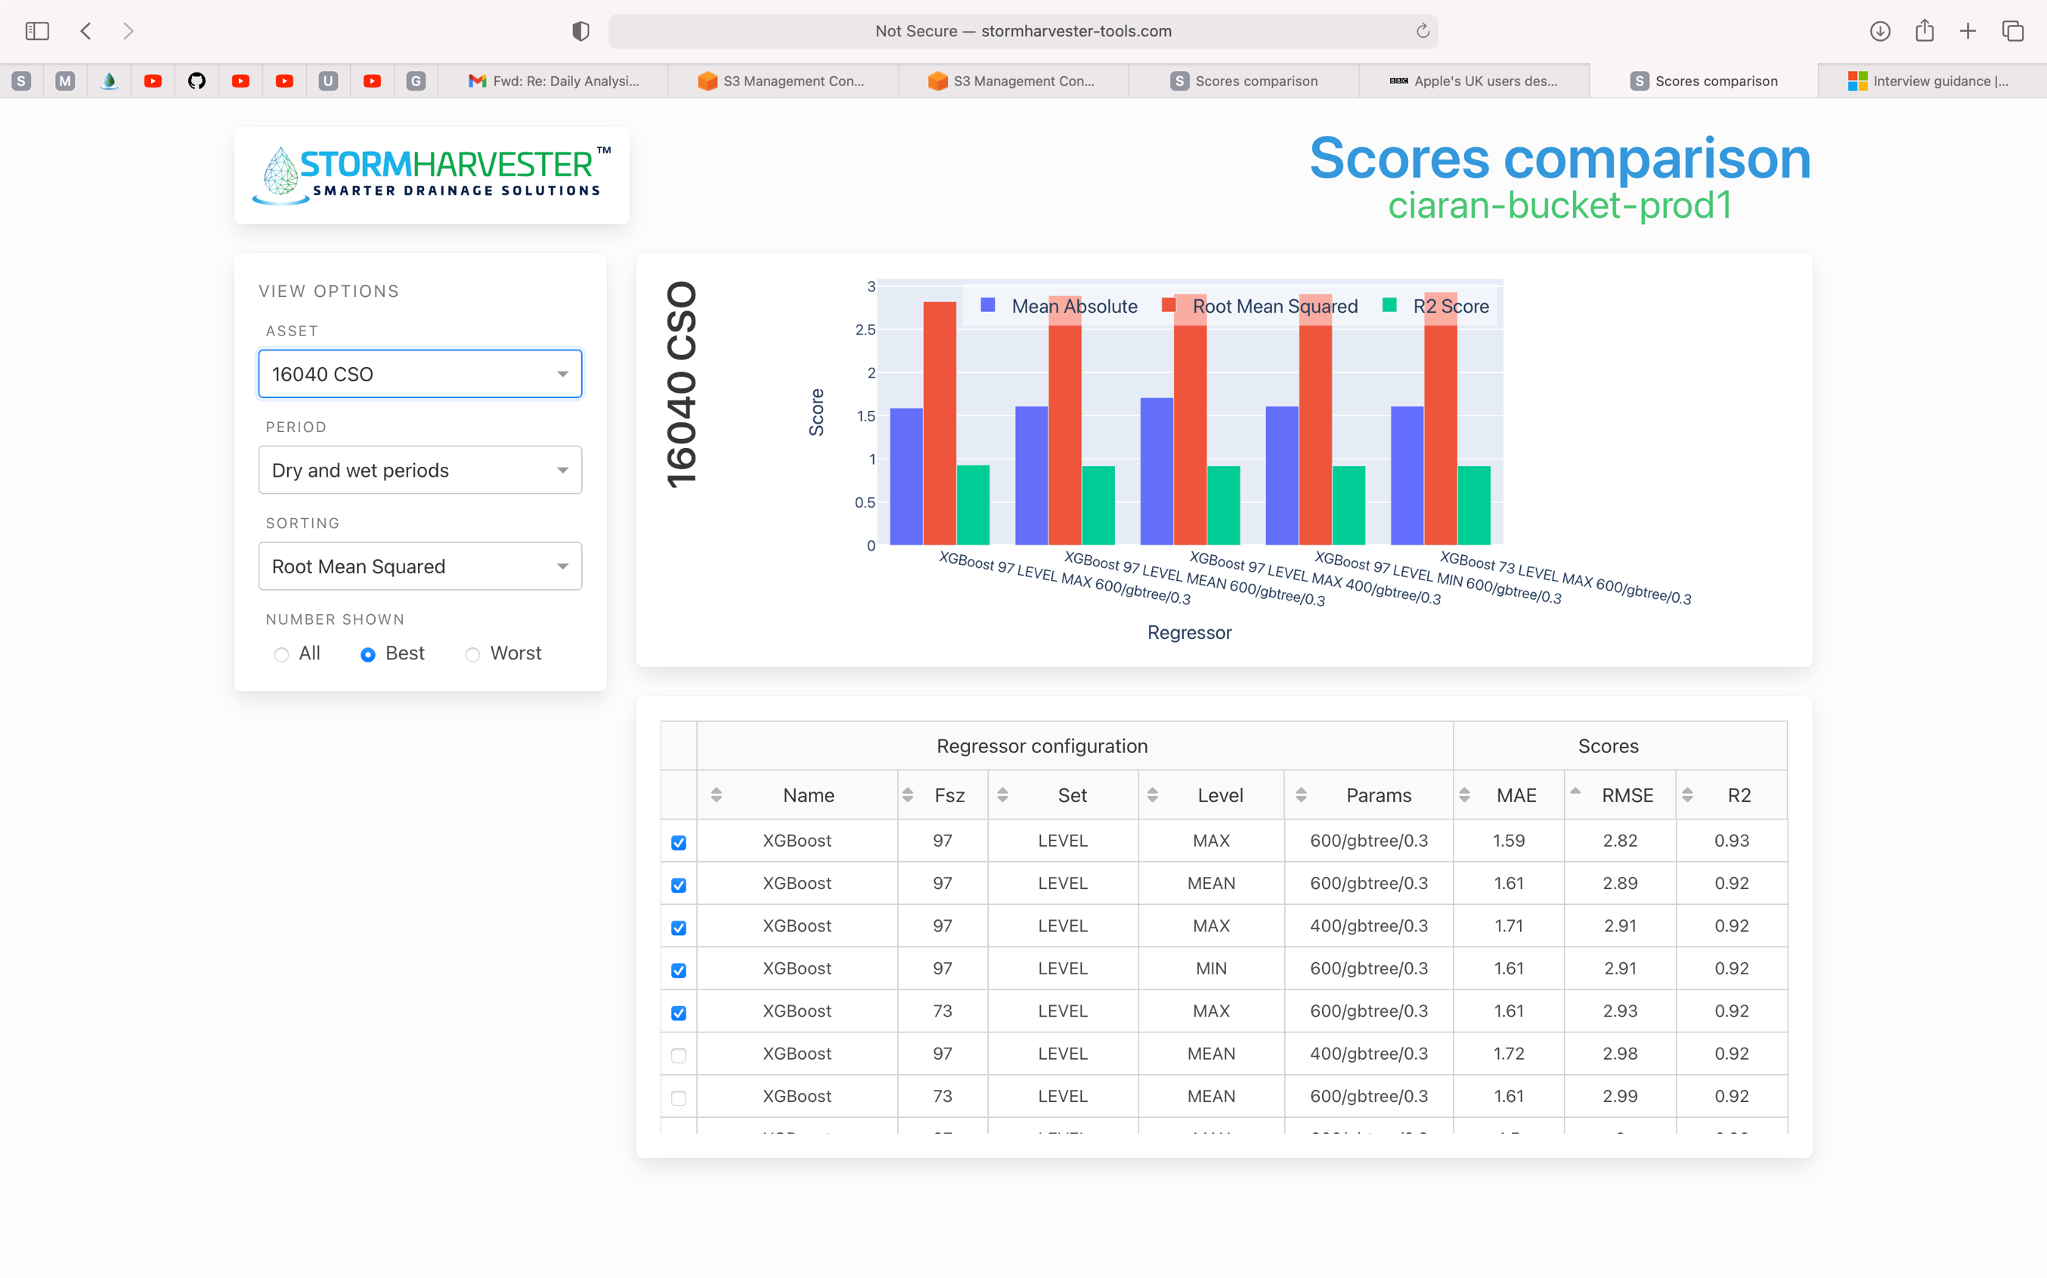

Asset 16762_CSO (ignore regressors)

*16762: Before Filter*

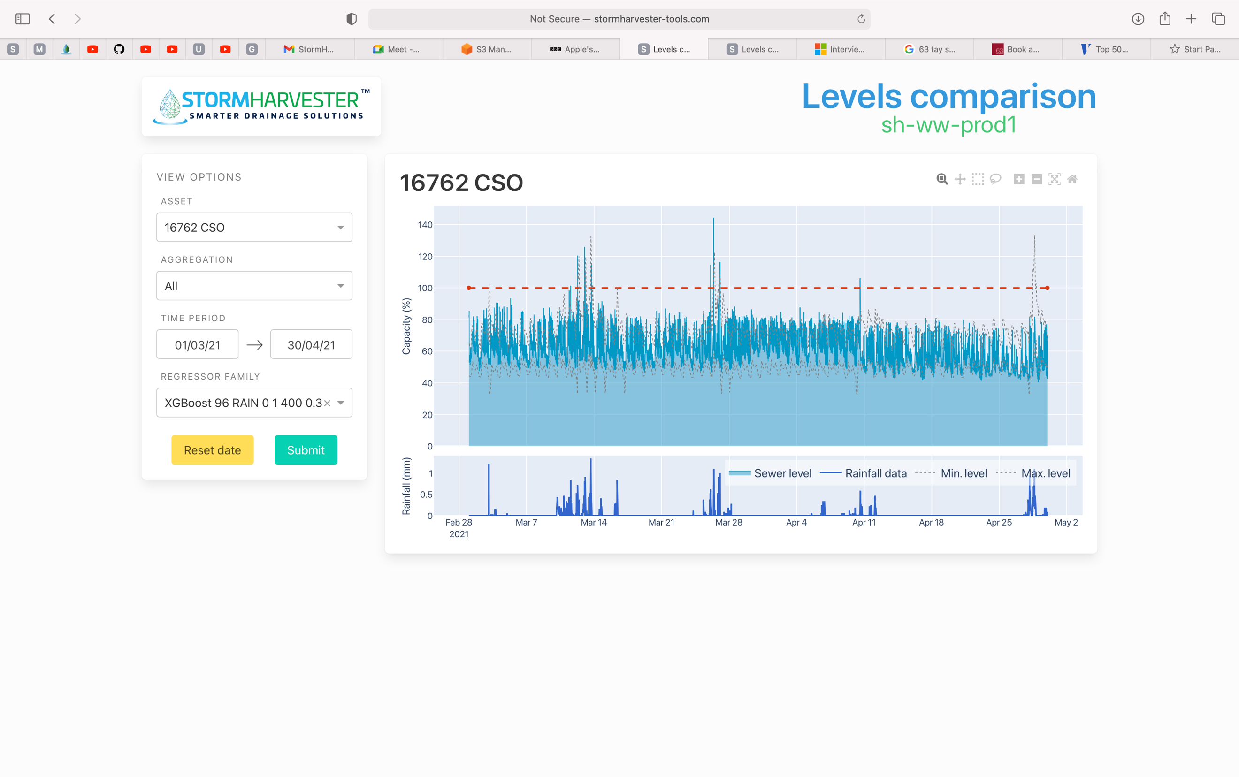

*16762: After Filter*

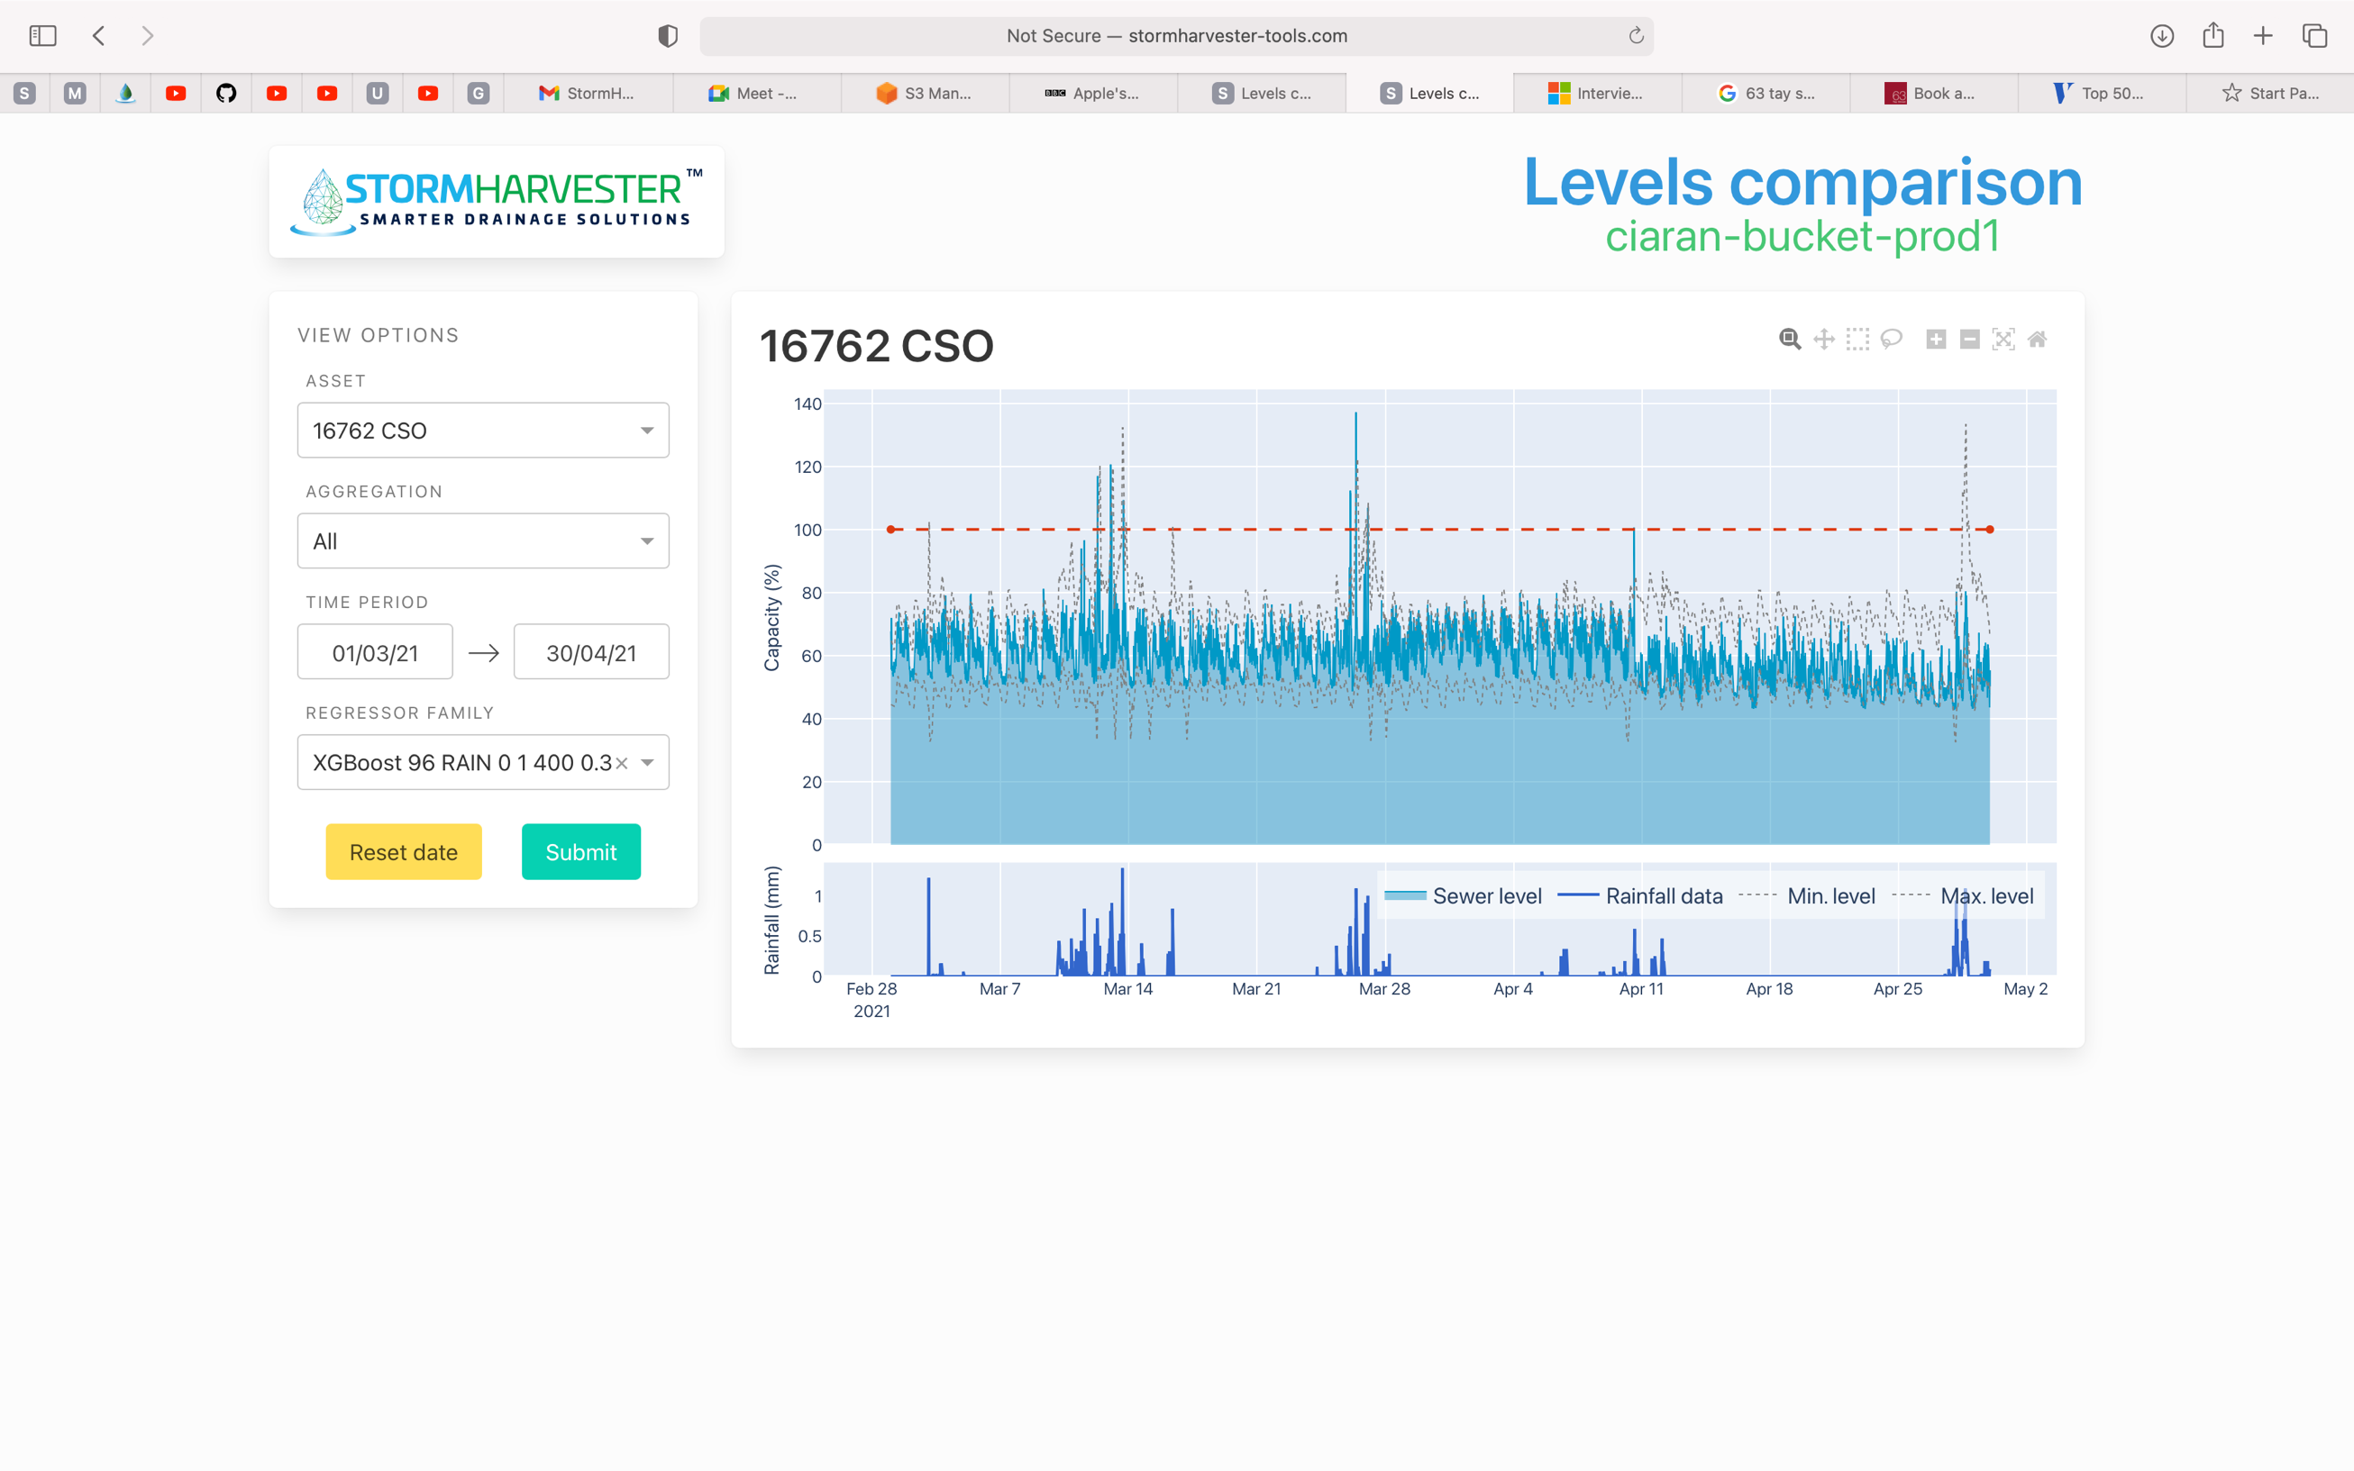

*New Regressor vs Old (Grey Dotted Line is the Old Regressor)*

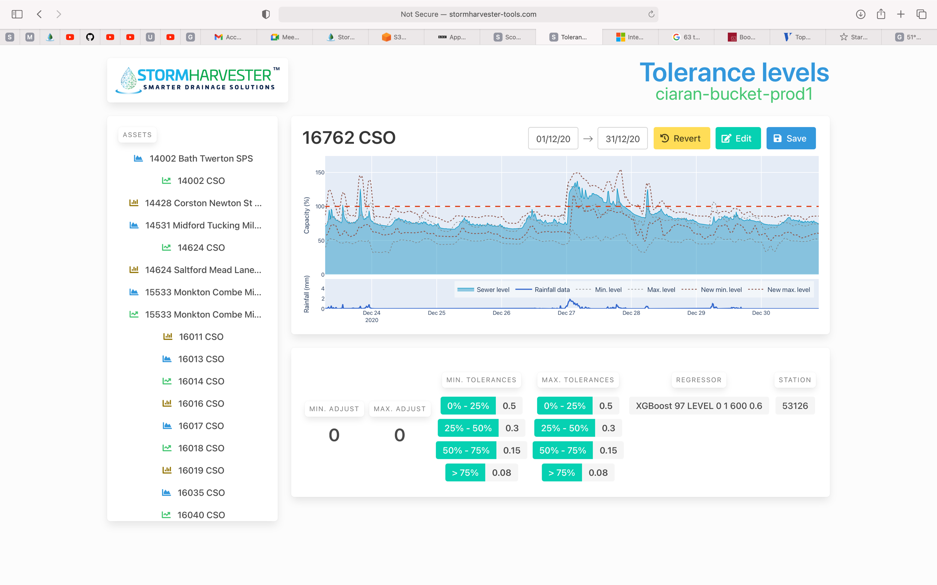

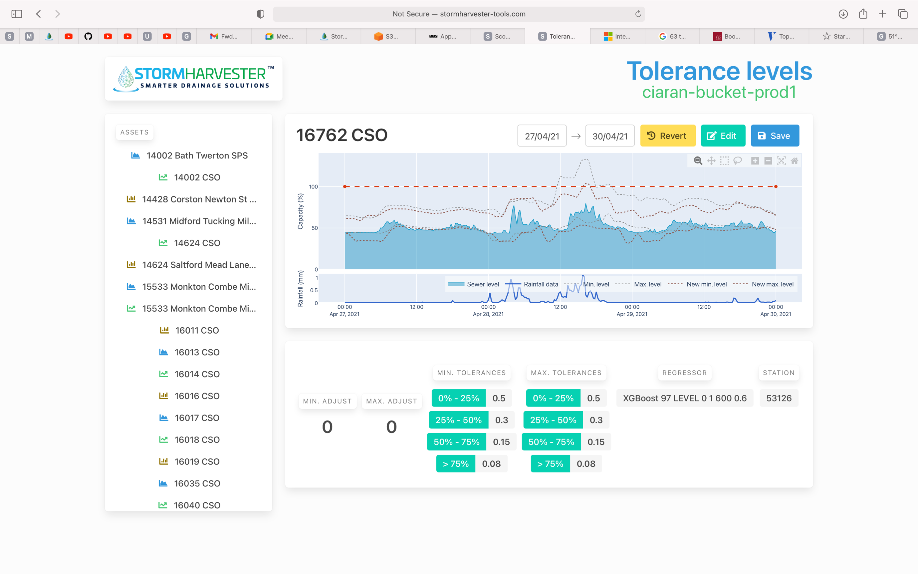

*Old Scores*

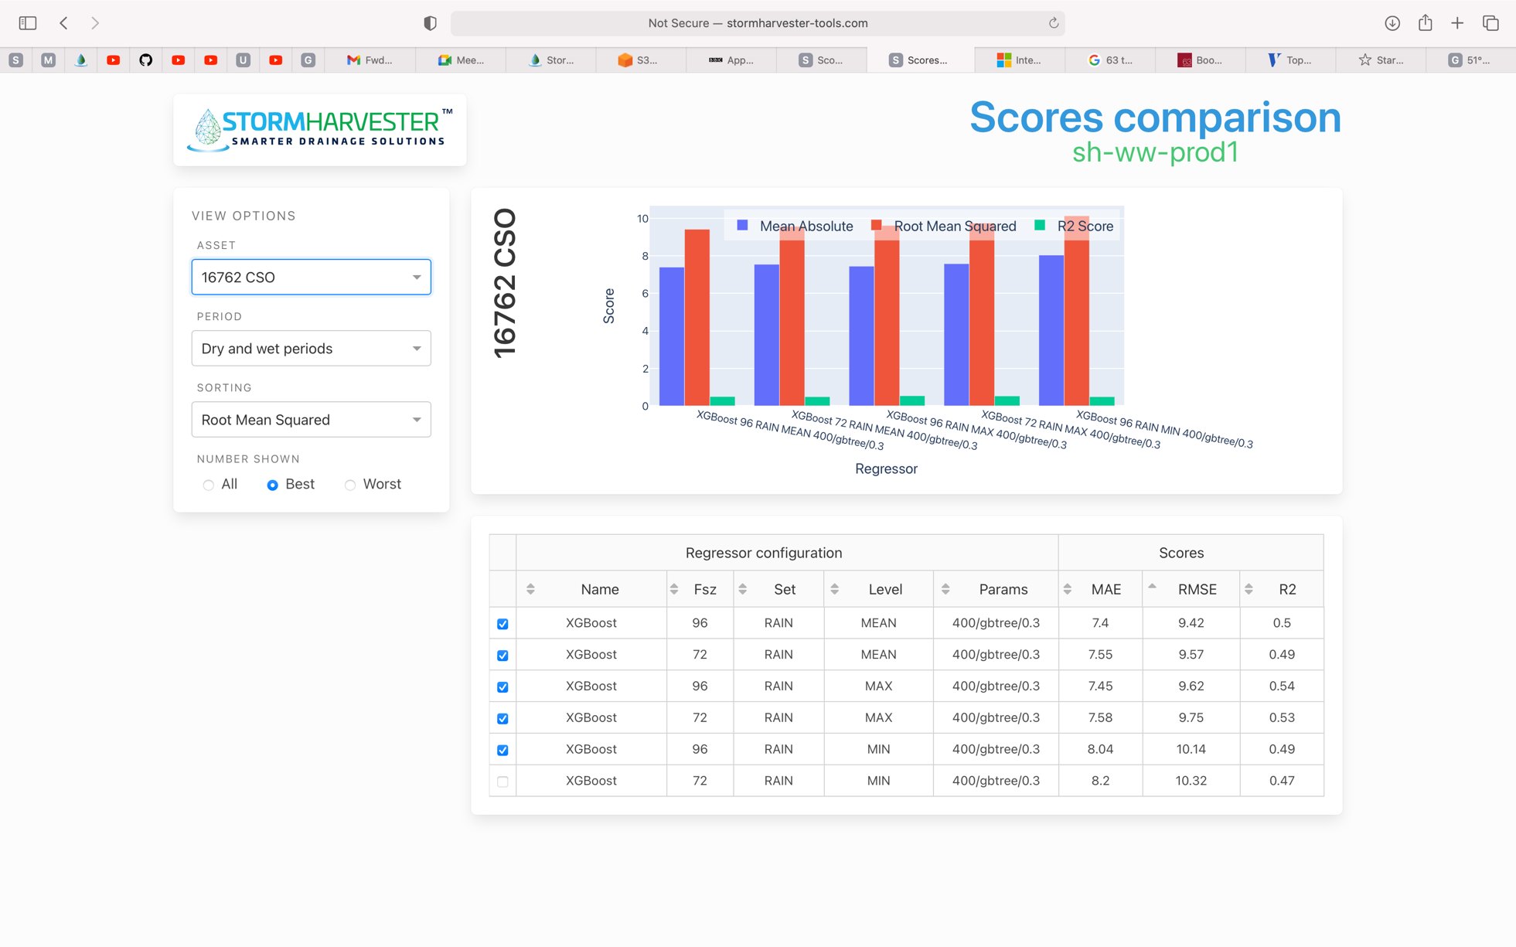

*New Scores*

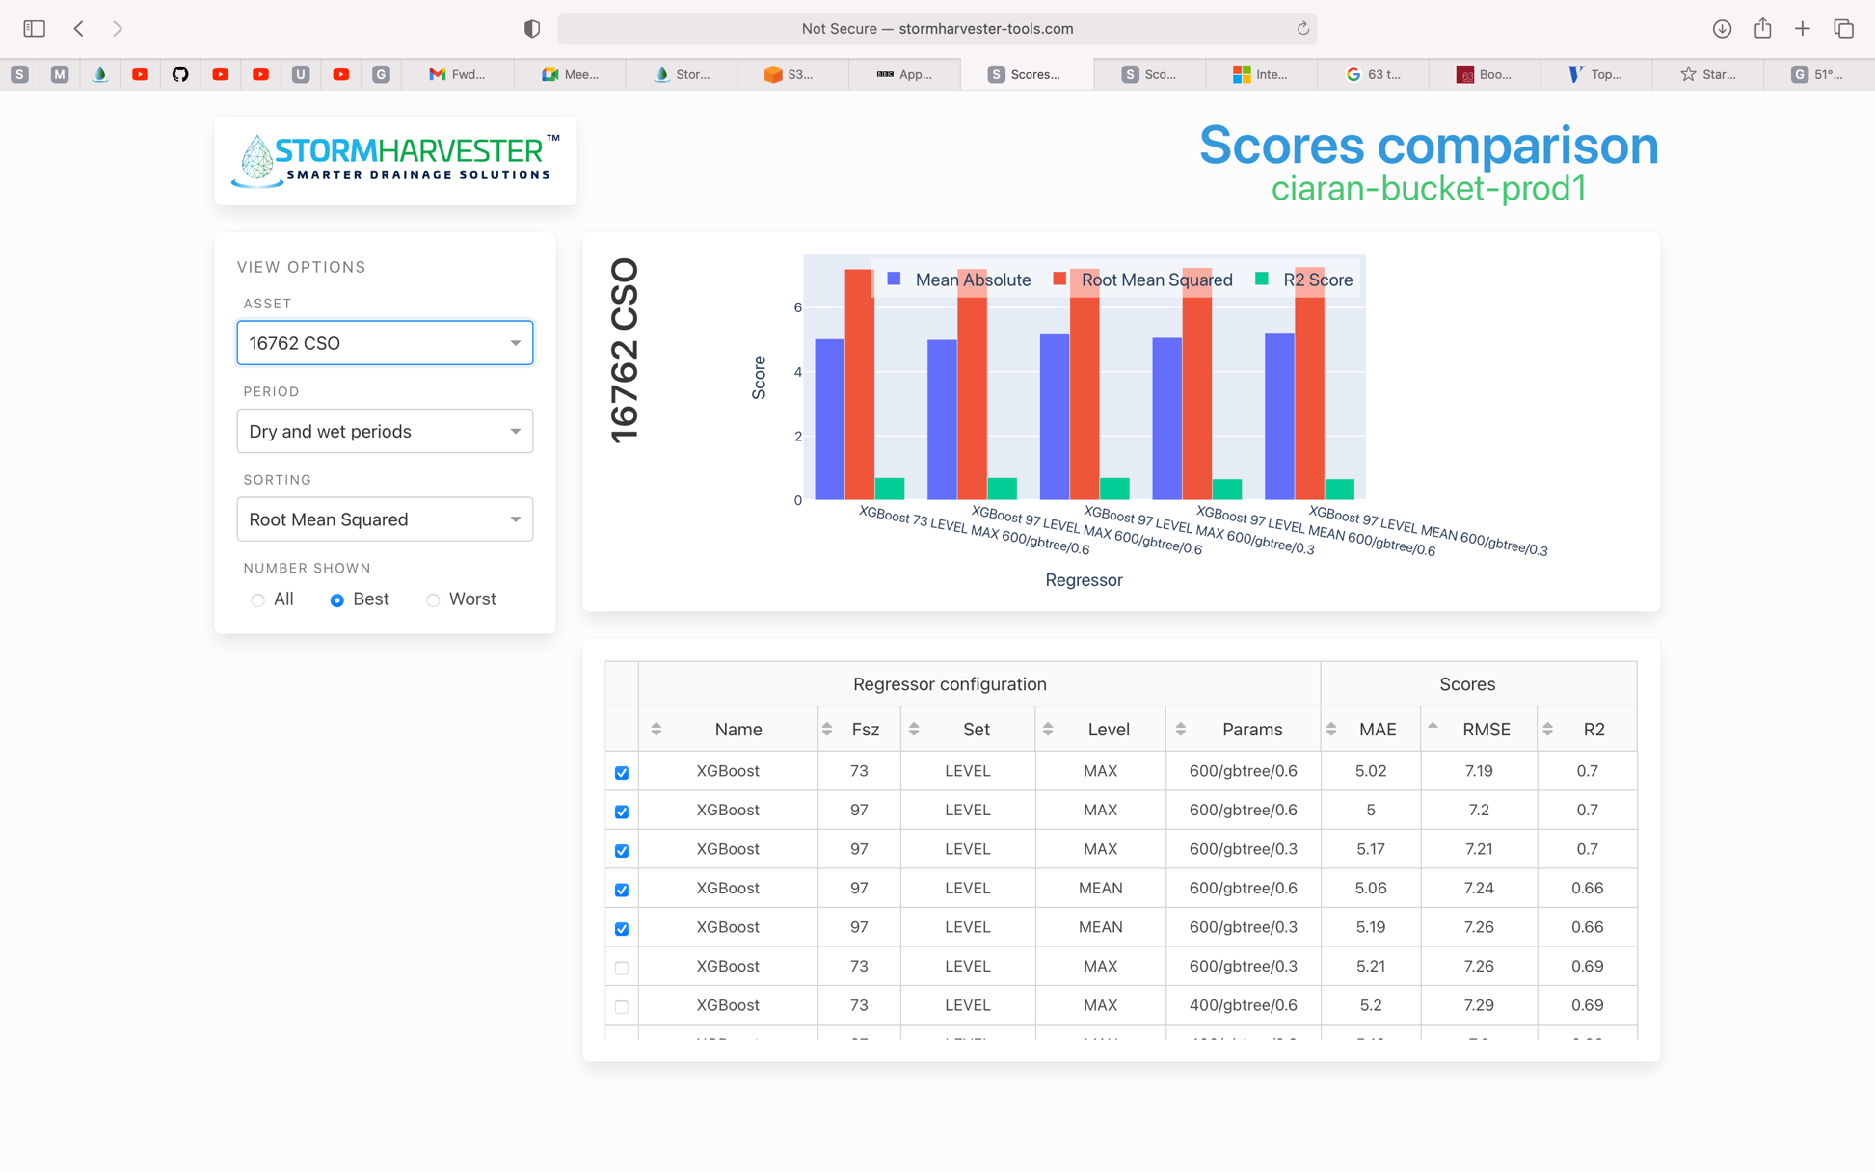

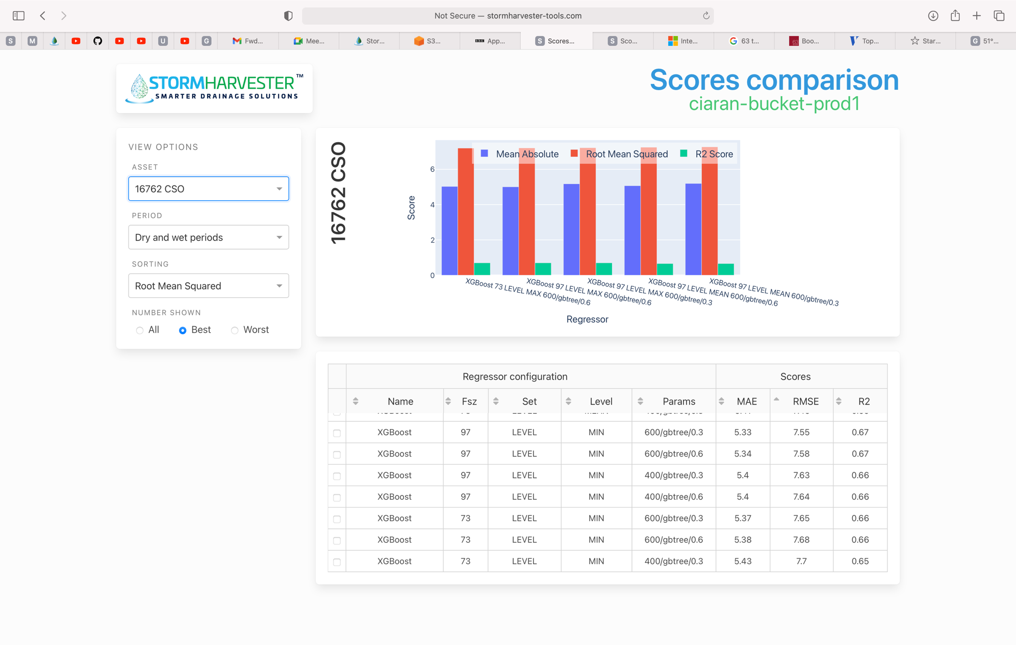

Asset 16090_CSO (ignore regressors)

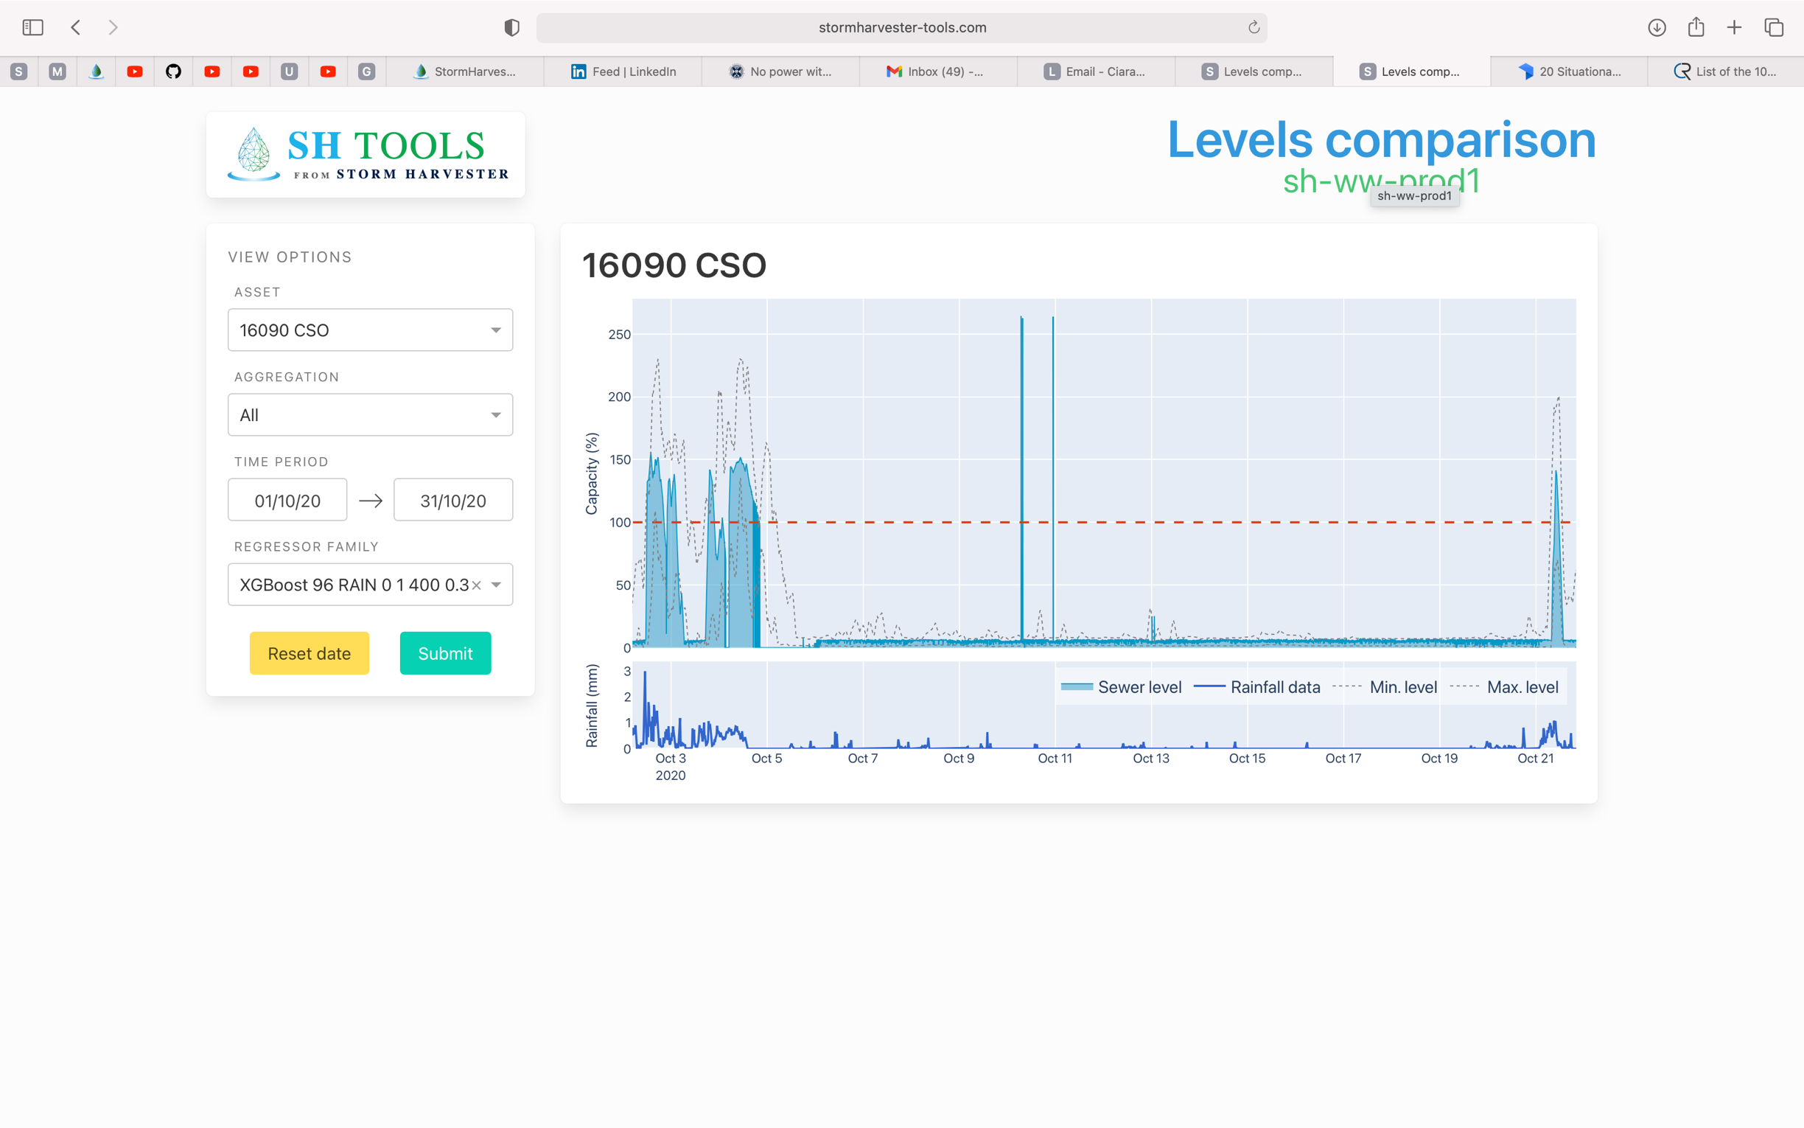

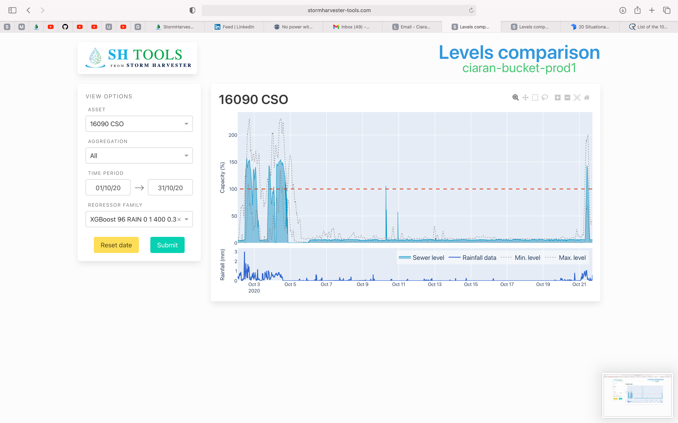

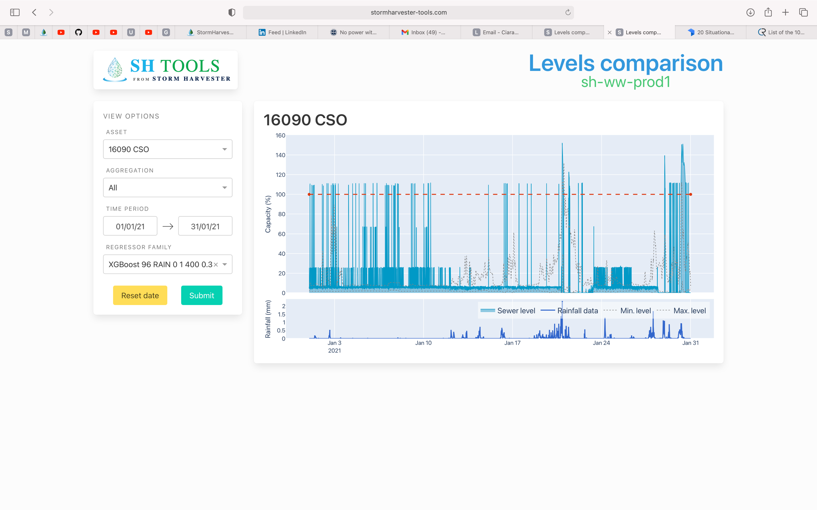

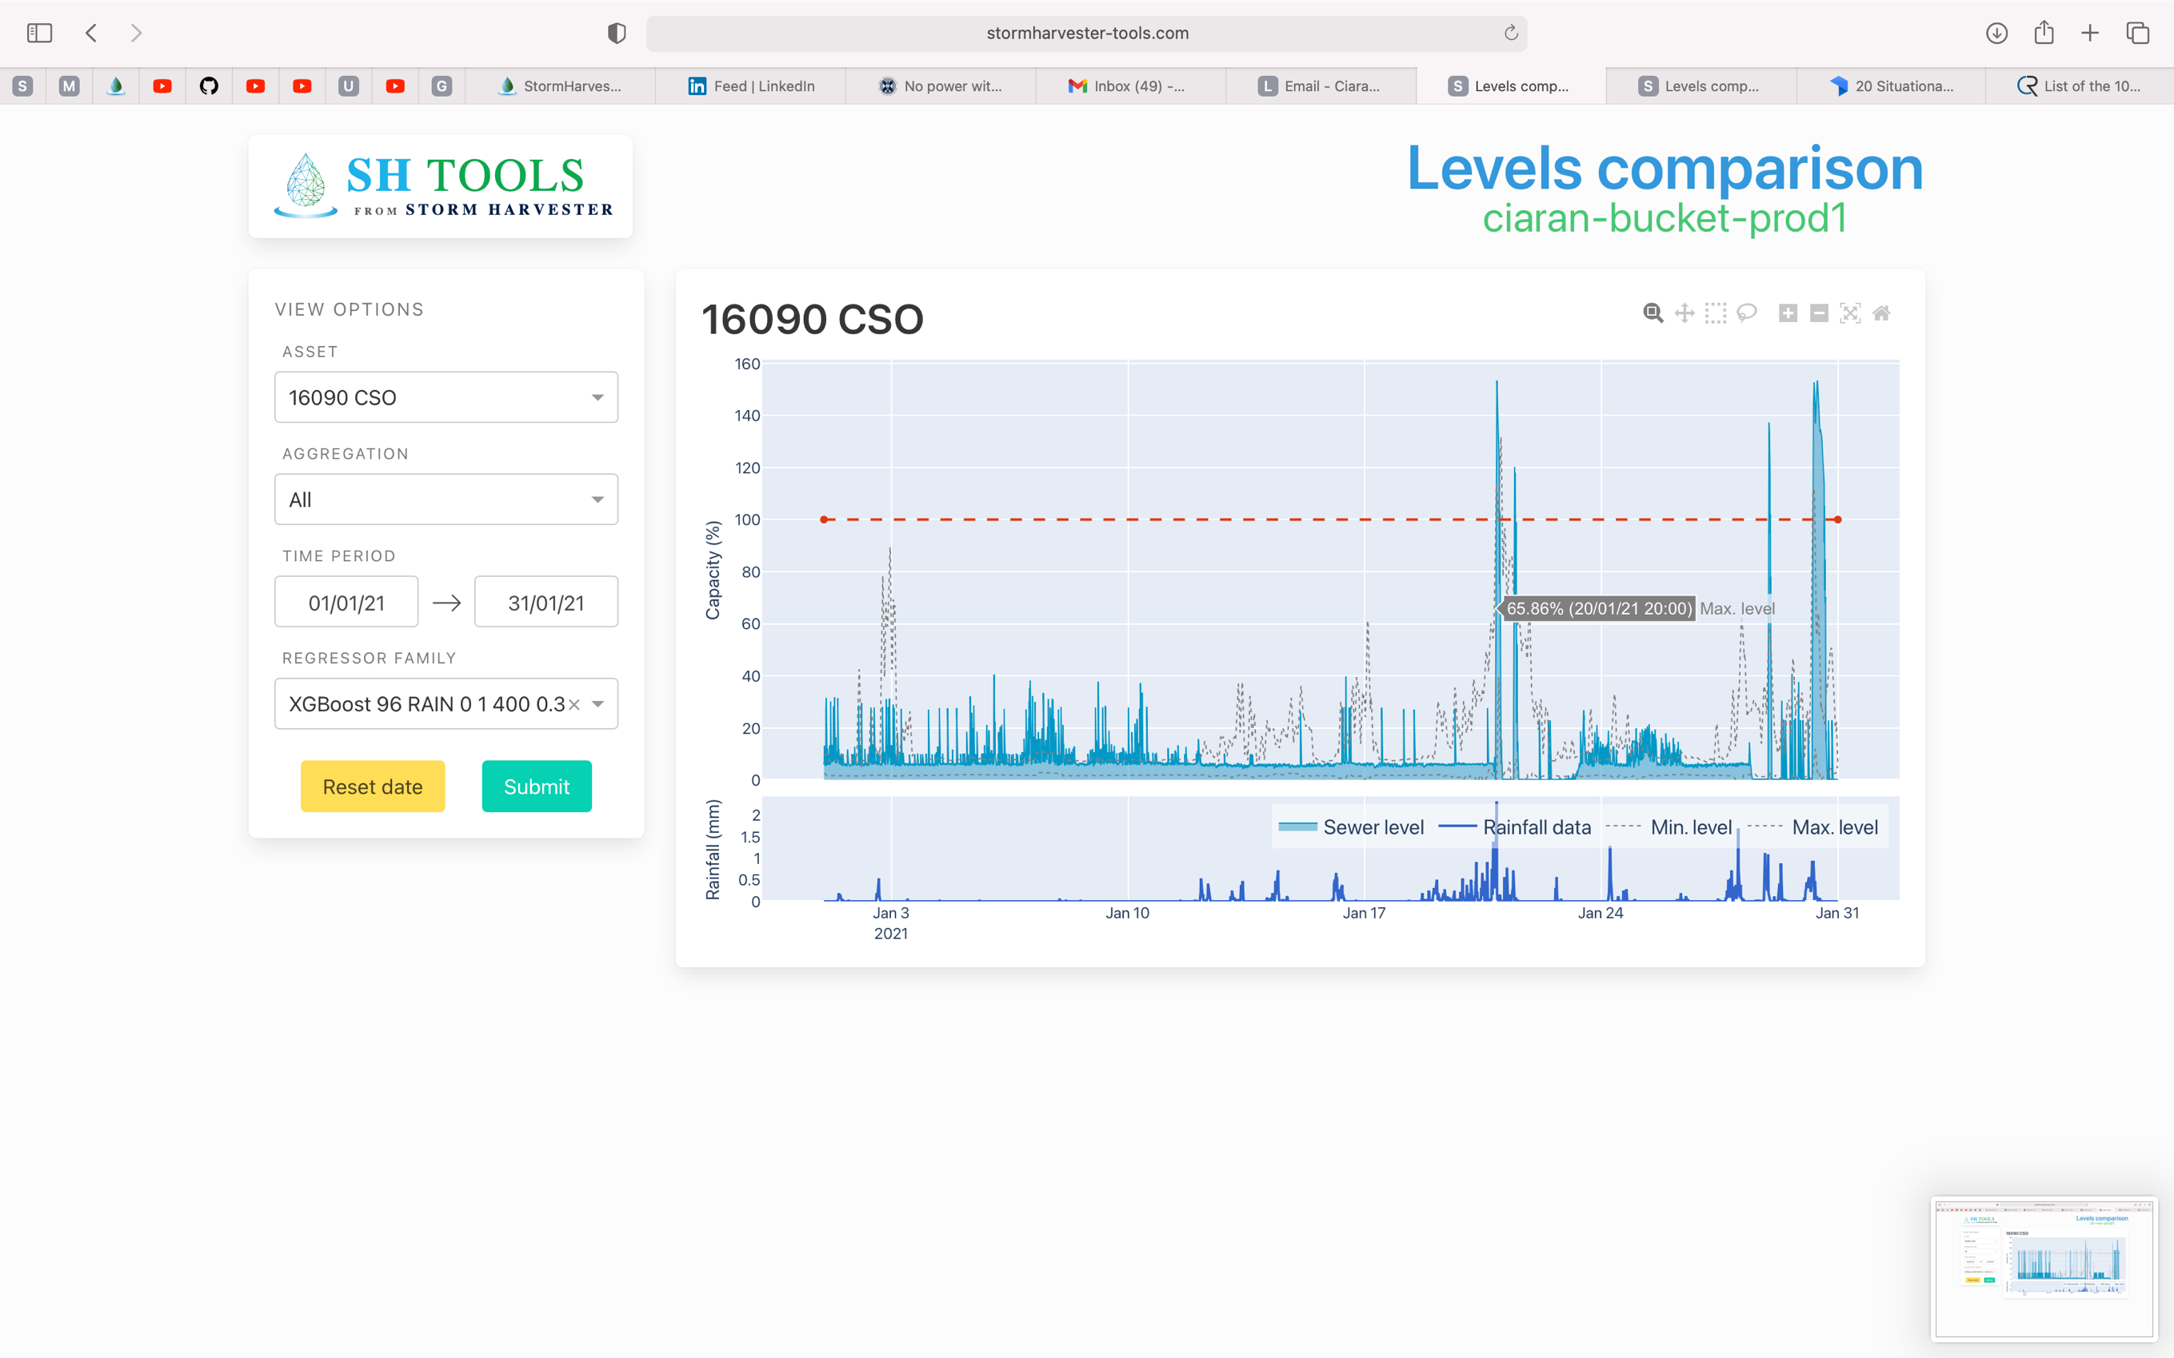

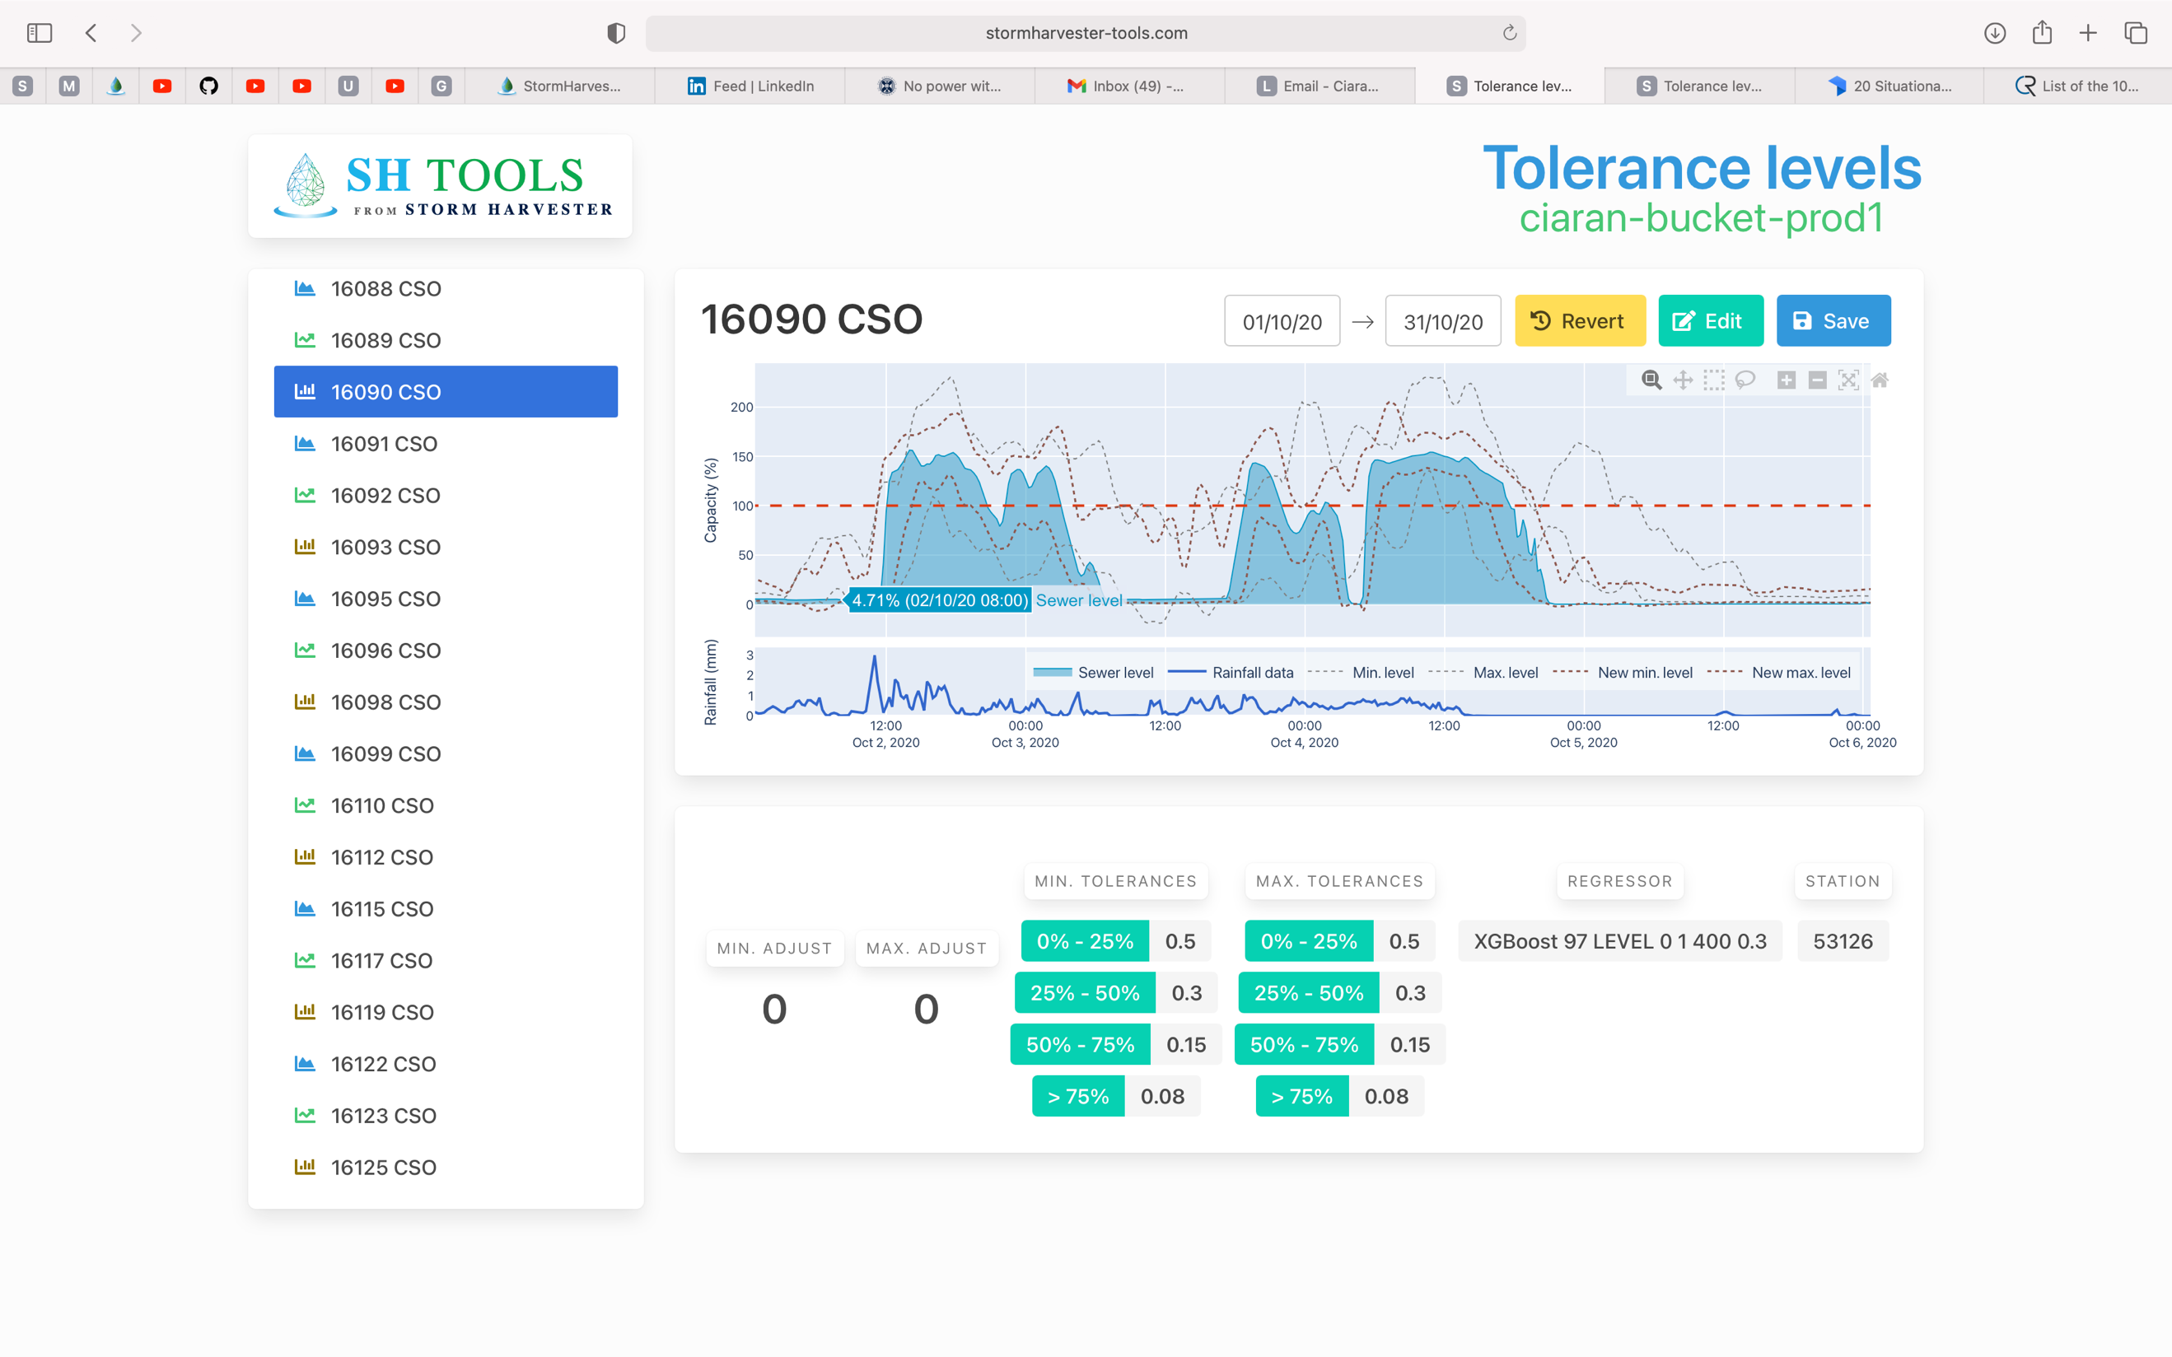

*Scores:*

*Before*

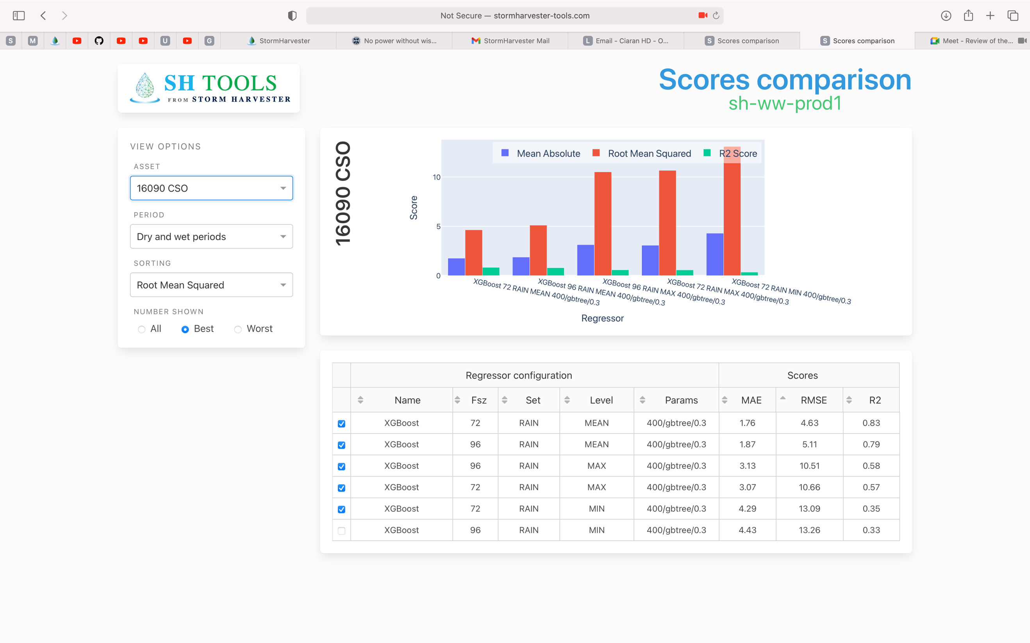

*After*

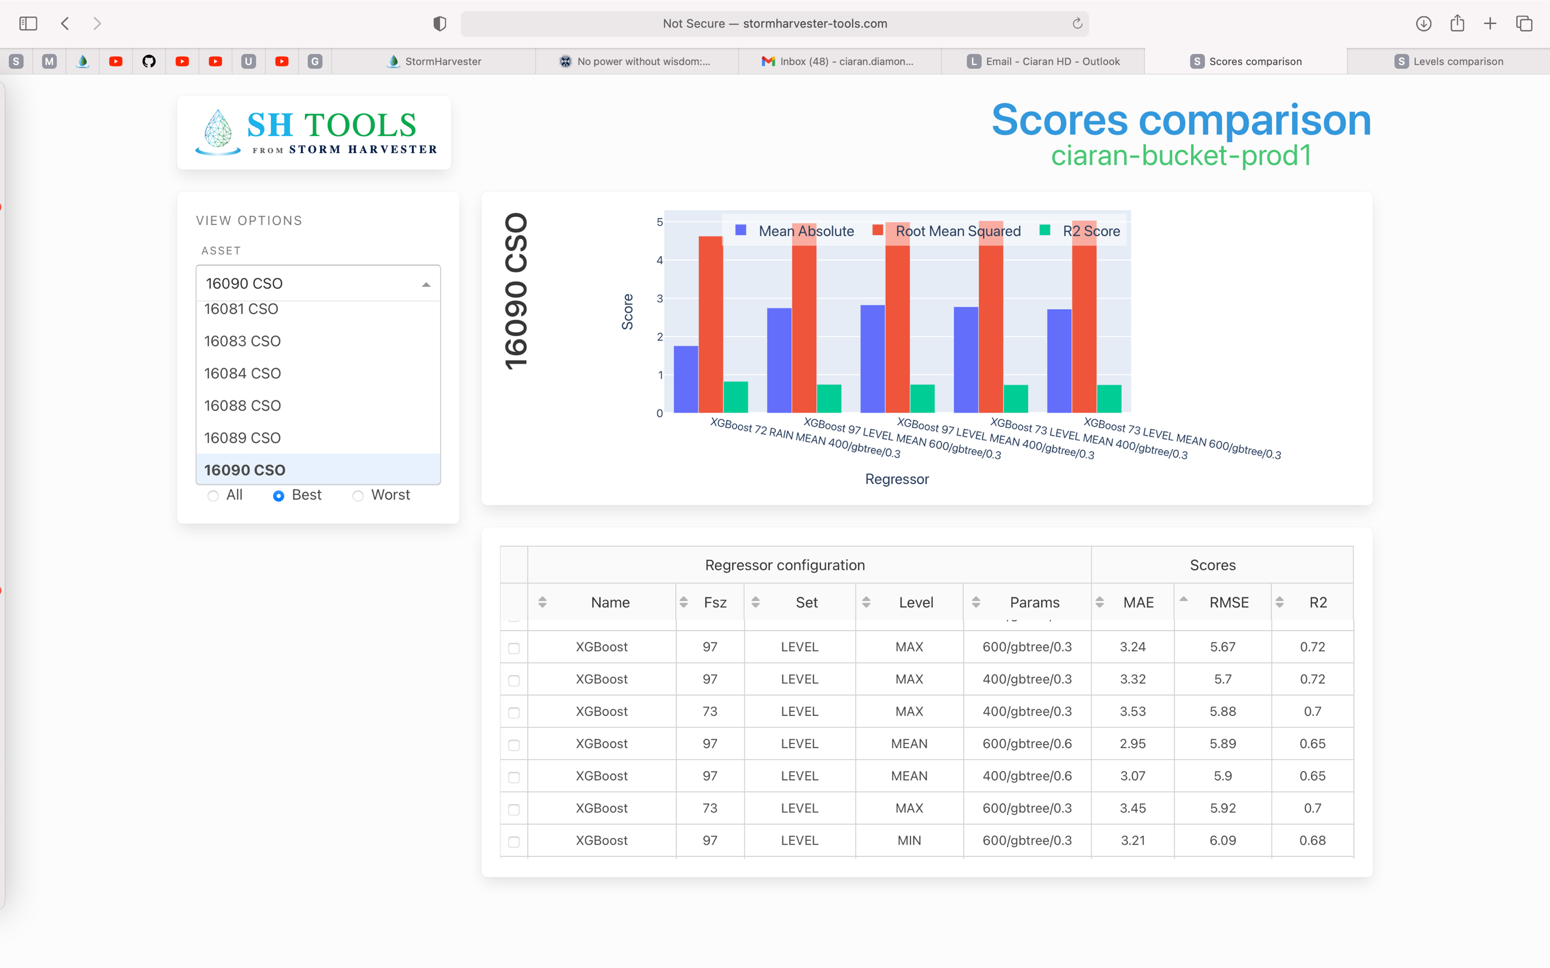

*I think there may be a relationship between filtered data and increasing the power of models when introducing river levels data. I’m not 100% on this, but I think high dimensional data might struggle to fit an accurate hyperplane to extremely noisy data. Only a theory though.*

*Stevie Request: Mapping Filtered Regressors Onto Unfiltered*

*Hypothesis: It won’t work.*

*Mapping the Regressor from filtered data onto the unfiltered data isn’t going to change anything to the human eye. Visually, the Regressor is a much better fit. And over the 15 minute intervals + they will look almost identical.*

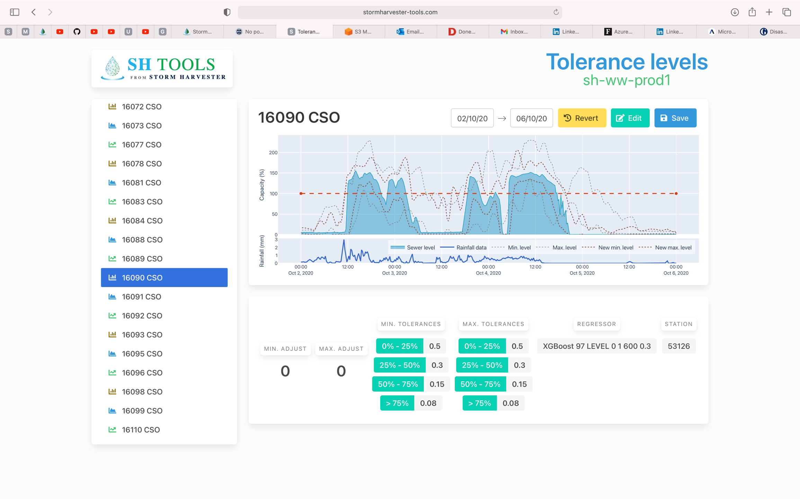

*Before*

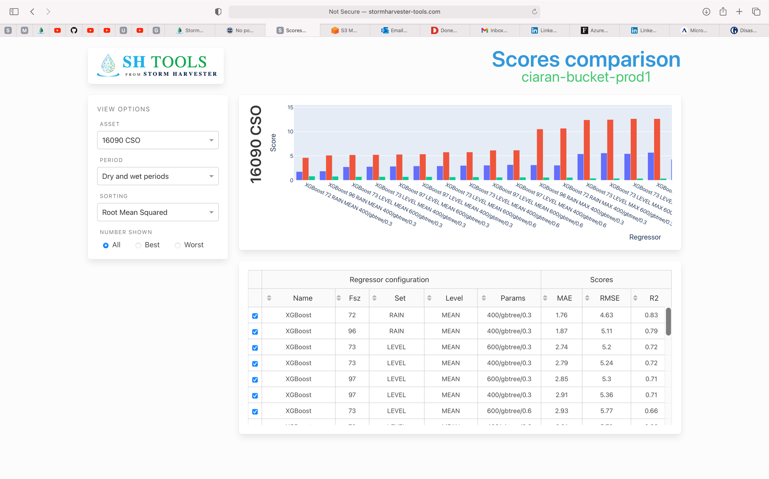

*After – Car Crash.*

*It defies what we see visually.*

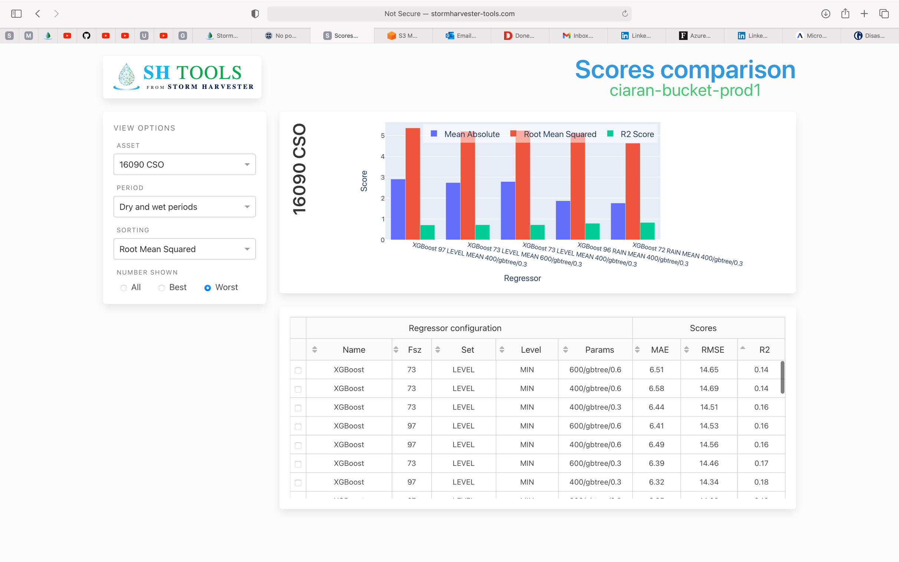

*Data – 2 minute Intervals (Very Different)*

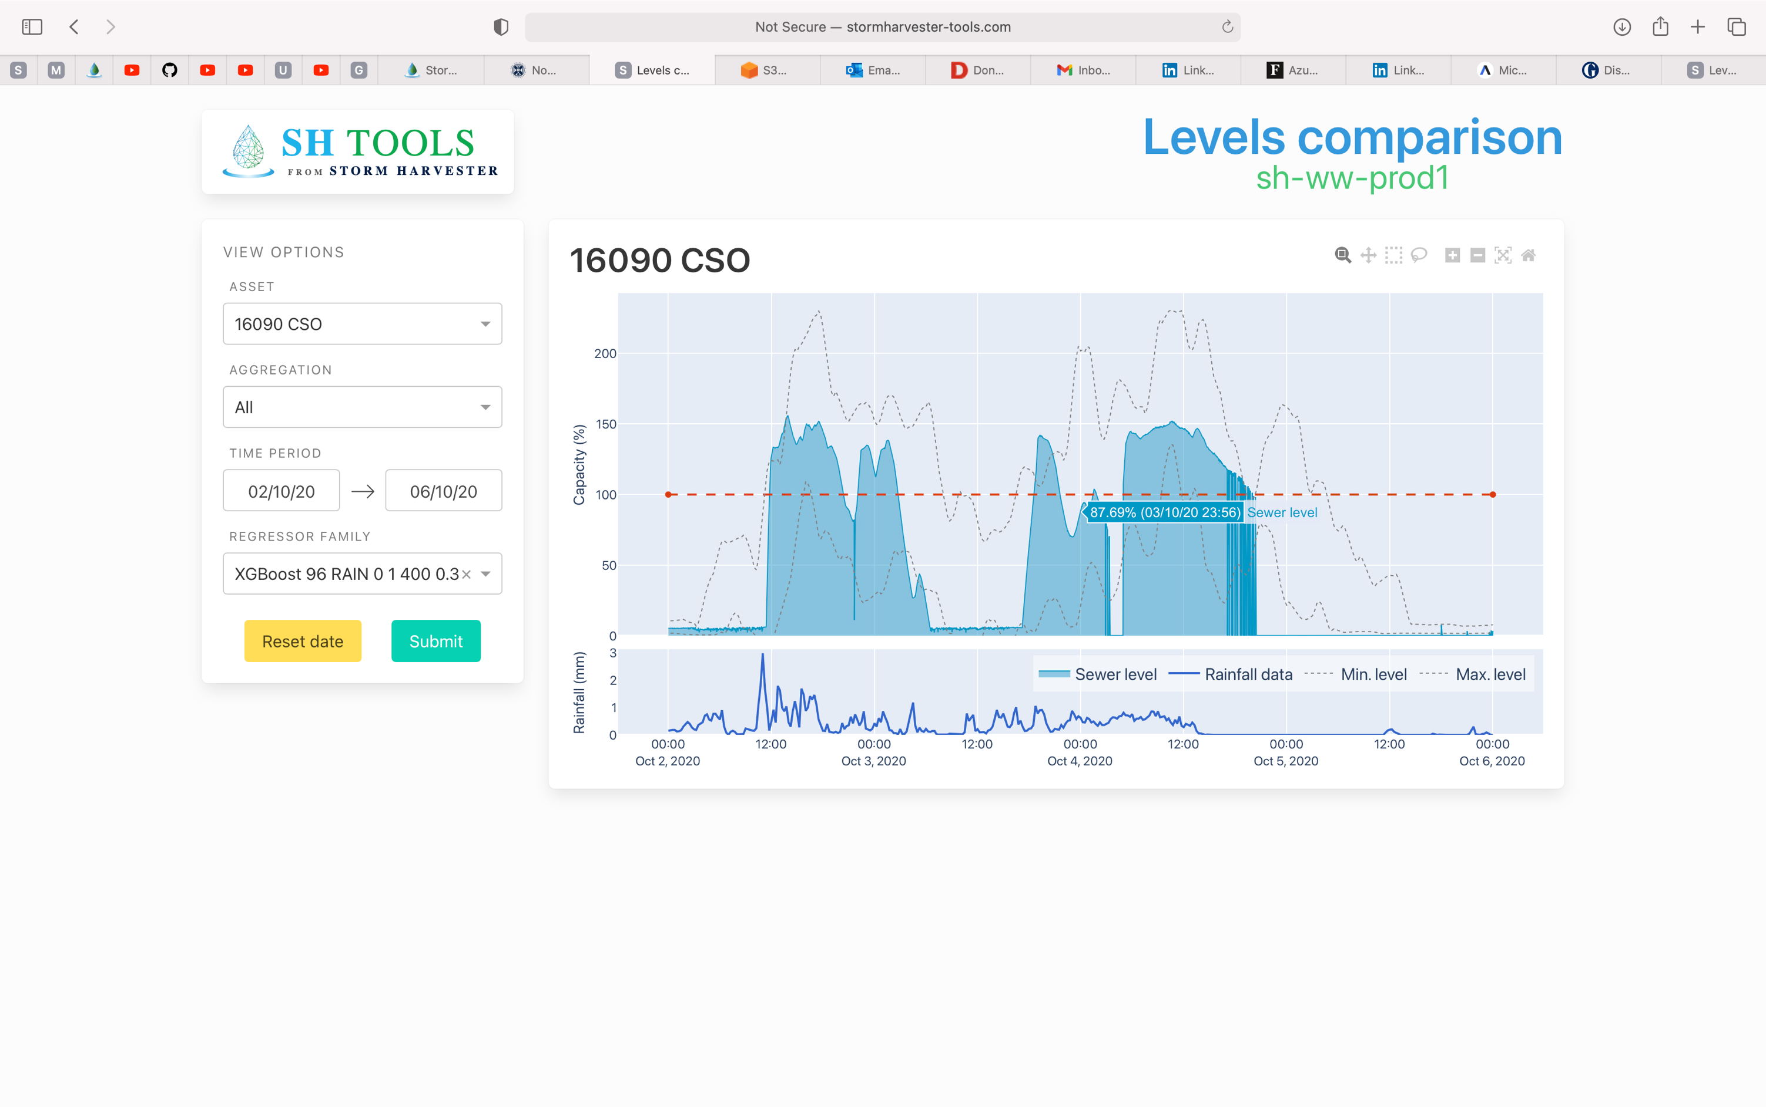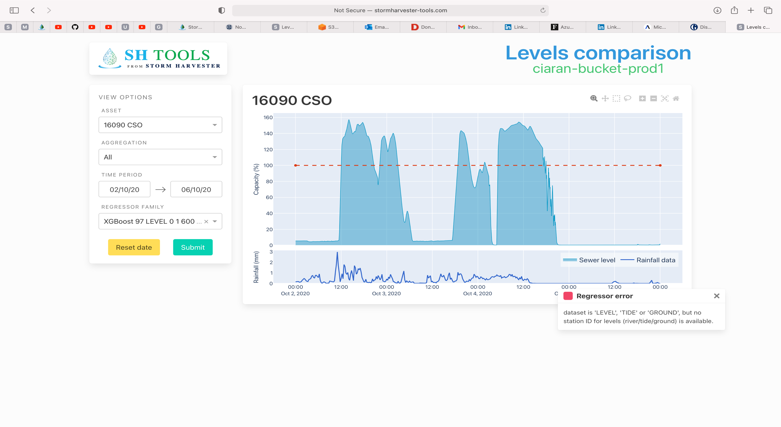

*Training the model on filtered data, and then applying it to the filtered unfiltered data makes no sense. When we train the machine learning model, the output is a mathematical expression for the optimum way to deal with the presented data. The unfiltered data is extremely volatile in places, and the model training process has to embed these characteristics into its output. Volatility makes fitting extremely difficult, especially when noise is random.*

*Applying a regressor which has not had to deal with the same level of volatility onto volatile data will not perform well and has no interpretative value.*

*Benching*

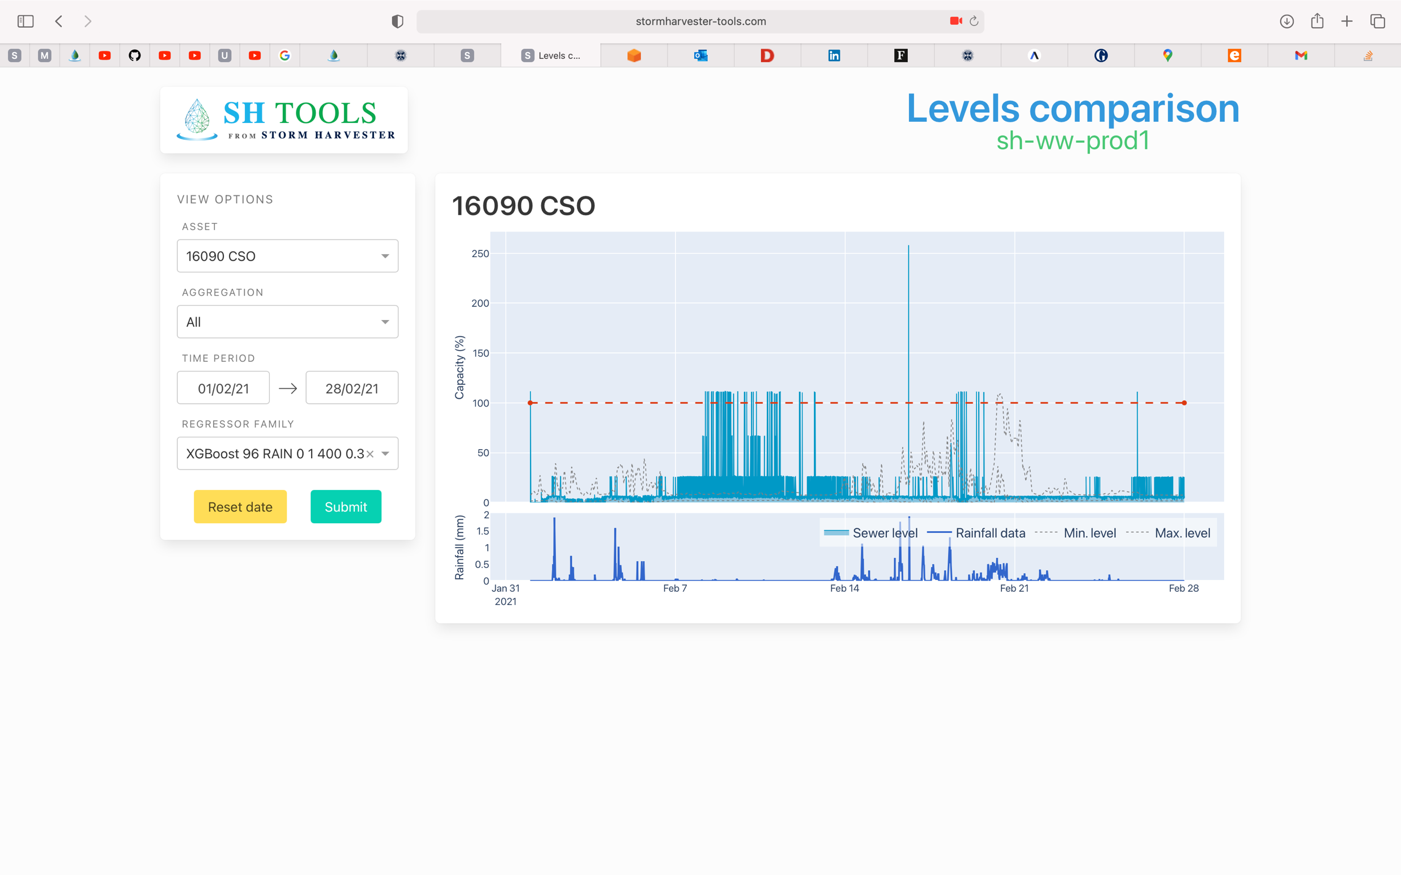

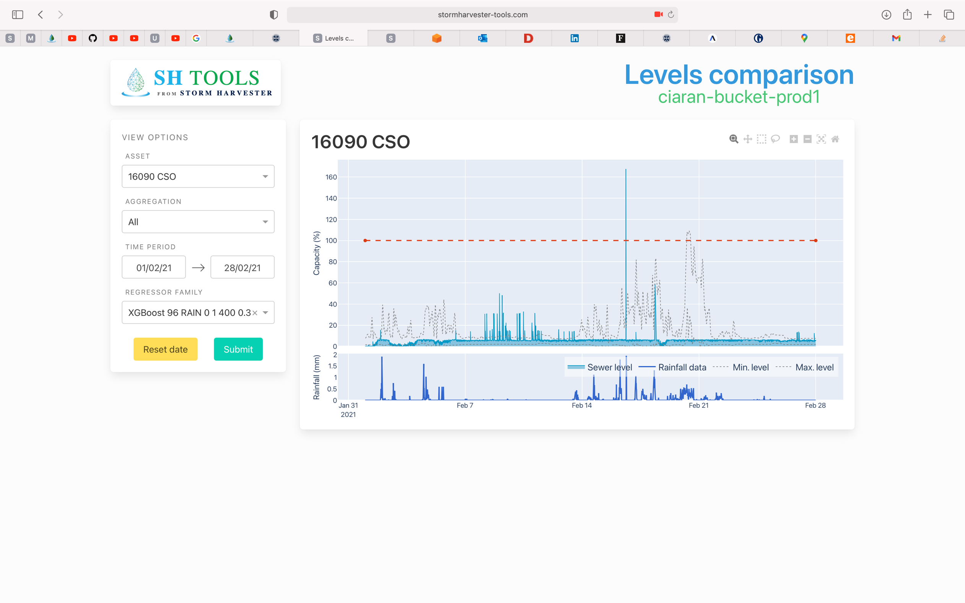

*Before*

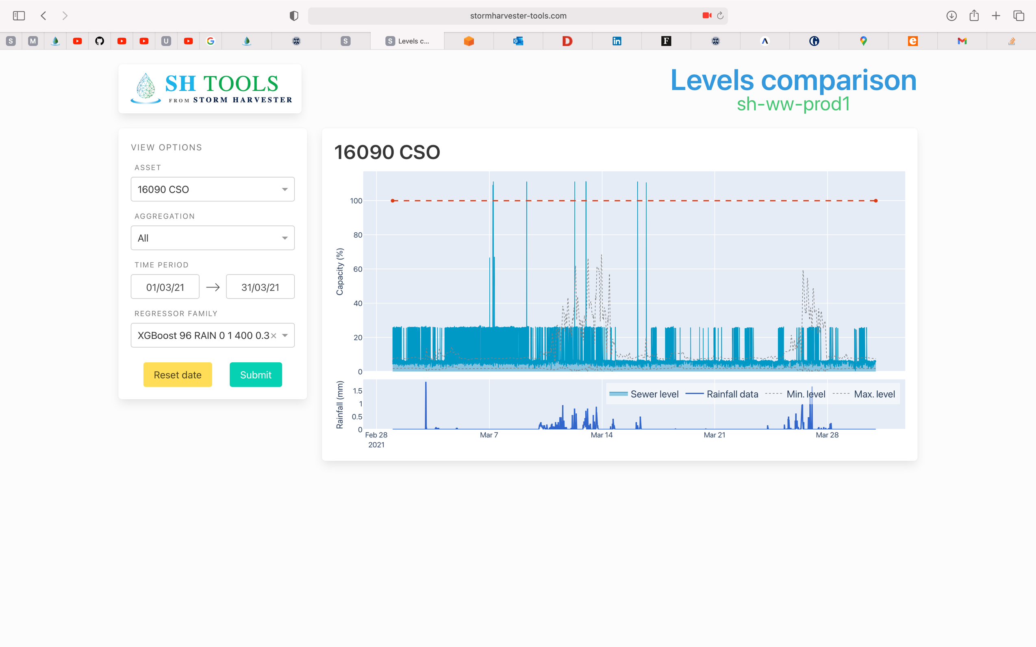

*After*

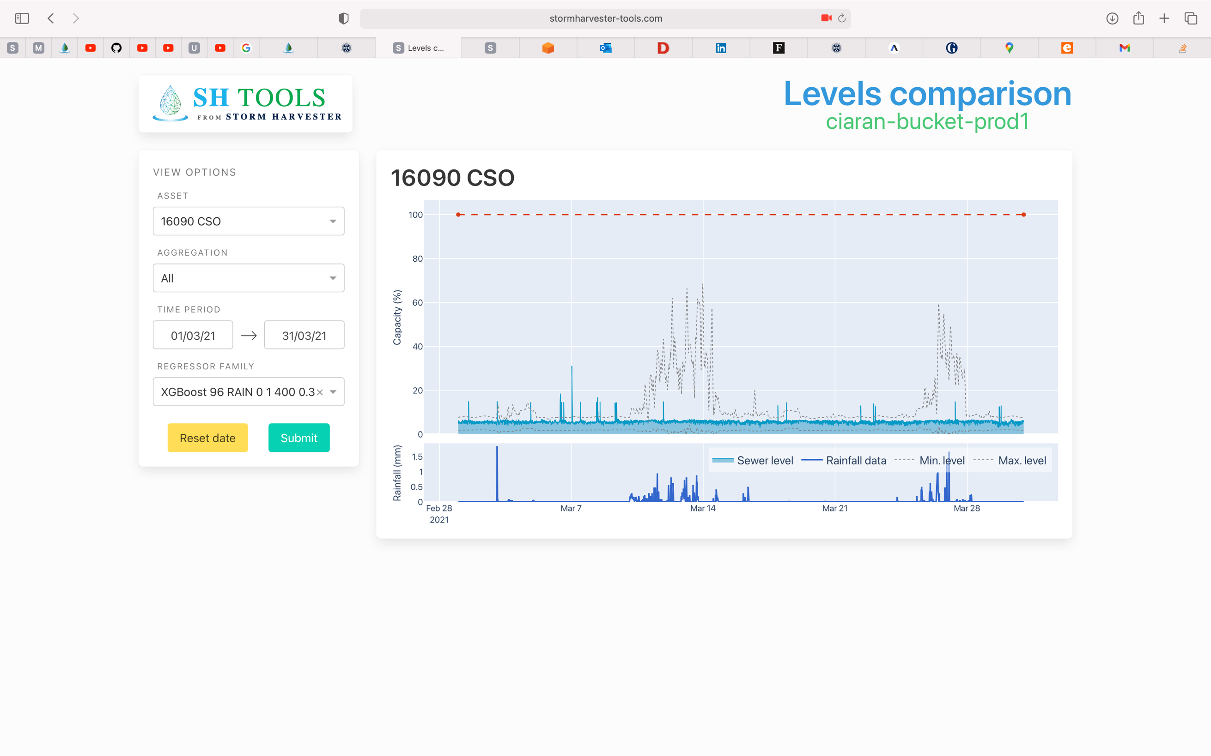

*Before*

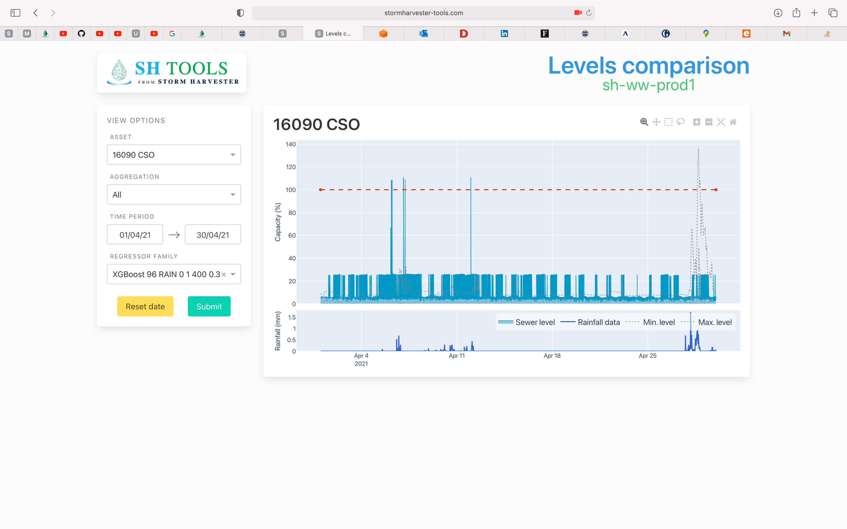

*After*

